**H₂O GUARDX: A Smart Framework for Water Safety Using ML, Blockchain & XAI**

**A PROJECT REPORT**

*Submitted by*

**Rahul Nair [RA2111027010009]**

**Ansab Aalim [RA2111027010030]**

**Ishaan Manhas [RA2111027010031]**

**Kshitij Rastogi [RA2111027010051]**

*Under the Guidance of*

**Dr. A. V. Kalpana**

(Associate Professor, Department of Data Science and Business Systems)

*In partial fulfillment of the Requirements for the Degree*

*of*

**BACHELOR OF TECHNOLOGY**

## COMPUTER SCIENCE ENGINEERING

## with specialization in Big Data Analytics



**DEPARTMENT OF DATA SCIENCE AND BUSINESS SYSTEMS**

**COLLEGE OF ENGINEERING AND TECHNOLOGY**

**SRM INSTITUTE OF SCIENCE AND TECHNOLOGY**

**KATTANKULATHUR – 603203**

**(Under Section 3 of UGC Act, 1956)**

SRM NAGAR, KATTANKULATHUR – 603203

CHENGALPATTU DISTRICT

**MAY 2025**



SRM INSTITUTE OF SCIENCE AND TECHNOLOGY

KATTANKULATHUR-603203

BONAFIDE CERTIFICATE

Certified that this project report titled “**H₂O GUARDX: A Smart Framework for Water Safety Using ML, Blockchain & XAI”** is the Bonafide work of **Rahul Nair [RA2111027010009], Ansab Aalim [RA2111027010030], Ishaan Manhas [RA2111027010031] and Kshitij Rastogi [RA2111027010051]** who carried out the project work under my supervision. Certified further, that to the best of my knowledge, the work reported herein does not form part of any other thesis or dissertation on the basis of which a degree or award was conferred on an earlier occasion for this or any other candidate.

Dr. A. V. Kalpana Dr. V. Kavitha

**GUIDE HEAD OF THE DEPARTMENT**

Associate Professor Department of Data Science and

Department of Data Science and Business Systems

Business Systems

Signature of Internal Examiner Signature of External Examiner

### Department of Data Science and Business Systems

**SRM Institute of Science and Technology**

**Own Work Declaration Form**

##### **Degree/ Course:** Bachelor of Technology, Computer Science and Engineering with Specialization in Big Data Analytics

**Student Name:** Rahul Nair, Ansab Aalim, Ishaan Manhas, Kshitij Rastogi

**Registration Number:** RA2111027010009, RA2111027010030, RA2111027010031, RA2111027010051

**Title of Work:** H₂O GUARDX: A Smart Framework for Water Safety Using ML, Blockchain & XAI

We hereby attest that the evaluation complies with the requirements set out by the Education Committee, the University Website, and the Rules and Regulations against academic misconduct and plagiarism**.

We confirm that all the work contained in this assessment is my / our own except where indicated, and that it have met the following conditions:

* Clearly cited all relevant sources and listed them all
* All quoted content (from books, the internet, etc.) was referenced and inserted inverted commas.
* Identified the origins of any images, data, etc. that I do not own
* Never used any of the previous or current reports or essays written by any other student.
* Acknowledged assistance from others (such as fellow students, technologists, statisticians, and outside sources) where appropriate.
* Compiling any additional standards for plagiarism listed on the university website or course handbook.

I am aware that any fraudulent claim made for this work will be punished in line with the rules and norms of the university.

| **DECLARATION:** |
| --- |
| I am aware of and understand the University’s policy on Academic misconduct and plagiarism and I certify that this assessment is my / our own work, except where indicated by referring, and that I have followed the good academic practices noted above. |
| Rahul Nair [RA2111027010009] ____________________  Ansab Aalim [RA2111027010030] ____________________  Ishaan Manhas [RA2111027010031] ____________________  Kshitij Rastogi [RA2111027010051] ____________________ |

**ACKNOWLEDGEMENT**

We sincerely appreciate **Dr. C. Muthamizhchelvan**, our esteemed Vice Chancellor, for serving as our guiding light in all of our undertakings.

We would like to thank **Dr. S. Ponnusamy**, our registrar, from the bottom of our hearts for his support.

We would like to sincerely thank **Dr. Leenus Jesu Martin M**, our dean of the College of Engineering and Technology, for bringing innovation to every execution.

We would like to sincerely thank **Dr. Revathi Venkataraman**, the Chairperson of the School of Computing, for giving us the courage to finish our course projects.

We would like to thank the course coordinators and professor **Dr. V. Kavitha,** Head of the Department of Data Science and Business Systems, for their unwavering encouragement and support.

We are very appreciative of the help, timely suggestions, and direction provided by our course project instructor, **Dr. A.V. Kalpana**, Associate Professor, Department of Data Science and Business Systems, during the project.

We would like to express our appreciation to the Department of DSBS, our HoD and Professor **Dr. V. Kavitha**, and my departmental colleagues for their support.

Finally, we would like to express our gratitude to our parents and close friends for their direct and indirect contributions to the accomplishment of our project. Above all, I am grateful to God for granting me the ability to finish my course assignment.

Rahul Nair [RA2111027010009]

Ansab Aalim [RA2111027010030]

Ishaan Manhas [RA2111027010031]

Kshitij Rastogi [RA2111027010051]

**ABSTRACT**

Access to clean drinking water is essential for public health and well-being. Water compatibility refers to the safety of drinking water for human consumption and includes various physical, chemical, and biological parameters. Contaminated water can cause serious health problems, including water-borne diseases, that disproportionately affect vulnerable populations. Traditionally, water quality assessment involves time-consuming laboratory testing, which can delay response to contamination. The H₂OGuardX project presents a novel approach that uses machine learning (ML) and deep learning (DL) algorithms to predict water sustainability based on key environmental factors such as pH, turbidity, and chemical contaminants. With these advanced methods, we aim to improve the efficiency and accuracy of water quality testing. To enhance trust, interpretability, and accountability in AI-driven predictions, the project incorporates Explainable AI (XAI) techniques such as SHAP (SHapley Additive Explanations) and LIME (Local Interpretable Model-agnostic Explanations). These methods provide insight into how individual features influence model predictions, making the decision-making process more transparent for stakeholders, including policymakers and health officials. Additionally, blockchain technology will be integrated to ensure secure and immutable storage of water quality data and promote data integrity and transparency. This paper discusses the methods of the H₂OGuardX project, evaluates the performance of different predictive models, and discusses the critical importance of blockchain in ensuring data security. With this innovative framework, we aim to enable more efficient and timely assessment of drinking water safety, ultimately contributing to improved public health outcomes.

**TABLE OF CONTENTS**

**CHAPTER NO. TITLE PAGE NO.**

ABSTRACT 4

TABLE OF CONTENTS 5

LIST OF FIGURES 7

ABBREVIATION 7

1. INTRODUCTION 1

1.1 GENERAL 1

1.2 PURPOSE 2

1.2.1 SCOPE 3

1.2.2 NEED FOR H₂OGUARD 4

1.3 SUSTAINABLE TECHNOLOGY 6

1.4 MOTIVATION 7

1.5 PROBLEM STATEMENT 9

1.6 RESEARCH OBJECTIVES 10

1. LITERATURE REVIEW 11

2.1 REVIEW PAPERS ON WATER POTABILITY PREDICTION 11

3. SPRINT PLANNING AND EXECUTION METHODOLOGY 16

3.1 SPRINT I 16

3.1.1 Objectives with user stories of Sprint I 16

3.1.2 Functional Document 16

3.1.3 Architecture Document 17

3.1.4 Outcome of objectives 17

3.1.5 Sprint Retrospective 17

3.2 SPRINT II 17

3.2.1 Objectives with user stories of Sprint II 18

3.2.2 Functional Document 18

3.2.3 Architecture Document 18

3.2.4 Outcome of objectives 19

3.2.5 Sprint Retrospective 19

3.3 SPRINT III 19

3.3.1 Objectives with user stories of Sprint III 19

3.3.2 Functional Document 19

3.3.3 Architecture Document 19

3.3.4 Outcome of objectives 19

3.3.5 Sprint Retrospective 19

4. PROPOSED METHODOLOGY 21

4.1 PROBLEM UNDERSTANDING AND SCOPE DEFINITION 21

4.1.1 Objective 21

4.1.2 Scope 22

4.1.3 Architecture Diagram 22

4.2 DATA COLLECTION 23

4.3 DATA PREPROCESSING 23

4.4 DATA EXPLORATION AND VISUALIZATION 24

4.5 FEATURE SELECTION AND ENGINEERING 25

4.6 MODEL SELECTION 25

4.7 MODEL TRAINING AND EVALUATION 26

4.8 MODEL TESTING AND DEPLOYMENT 27

4.9 REPORTING AND DOCUMENTATION 29

5. MODULE / EMPIRICAL STUDY 30

5.1 Pre-processing techniques 30

5.2 Segmentation 30

5.3 Feature extraction 31

5.4 Feature selection 31

5.5 Evaluation 33

5.6 Final Prediction 36

6. CONCLUSION 39

7. FUTURE ENHANCEMENT 40

8. REFERENCES 42

APPENDIX A CODING 43

APPENDIX B OUTPUT 49

APPENDIX C PUBLICATION STATUS 60

APPENDIX D PLAGIARISM REPORT 63

**LIST OF FIGURES**

**CHAPTER NO. TITLE PAGE NO.**

##### 4.1.3 Architecture Diagram 34

4.7.1 Model Evaluations 35

4.8.1 Model Accuracy36

4.8.2 Confusion Matrix 37

**ABBREVIATIONS**

AI - Artificial Intelligence

XAI – Explainable Artificial Intelligence

ML - Machine Learning

DL - Deep Learning

DNN - Deep Neural Network

IoT - Internet of Things

RF - Random Forest

SVM - Support Vector Machine

pH - Potential of Hydrogen (measure of acidity/alkalinity)

TDS - Total Dissolved Solids

KNN - K-Nearest Neighbours

IQR - Interquartile Range

WQI - Water Quality Index

WHO - World Health Organization

NGO - Non-Governmental Organization

GIS - Geographic Information System

**CHAPTER 1**

**INTRODUCTION**

**1.1 GENERAL**

Water quality is fundamental to public health, ensuring that both developed and developing nations can provide their populations with safe drinking water. Despite global advancements, access to clean water remains a significant issue. According to the World Health Organization (WHO), approximately 785 million people lack basic drinking-water services, leading to millions of deaths each year from waterborne diseases such as cholera, dysentery, and typhoid. These diseases disproportionately affect vulnerable populations, especially in regions where water contamination goes undetected or untreated for long periods. Traditional methods of water testing, such as laboratory-based chemical analyses, are often slow, costly, and require specialized expertise. This delay can prove dangerous in areas with limited regulatory oversight or infrastructure, where the response time to contamination is critical.

Moreover, water scarcity affects over 40% of the global population, and with increasing pollution from industrial and agricultural runoff, the risk of contamination grows. Ensuring access to safe drinking water becomes even more challenging as climate change exacerbates these issues. In regions where water is plentiful, pollutants from various sources continue to pose health risks. In light of these challenges, there is a need for innovative and more efficient methods to monitor water quality, ensuring the timely identification of contamination and mitigating potential public health risks.

Recent advances in technology, such as machine learning (ML), blockchain, and Explainable AI (XAI) provide promising solutions to these longstanding problems, offering opportunities for real-time monitoring and secure data management in water quality assessment. Explainable AI (XAI) makes predictive models more transparent by enabling stakeholders to comprehend the ways in which particular water quality parameters affect choices. This interpretability encourages more responsible, knowledgeable decision-making and increases confidence in AI-driven systems.

**1.2 PURPOSE**

The purpose of the H₂OGuardX project is to develop an efficient, real-time water quality monitoring system that leverages cutting-edge technologies such as machine learning (ML), deep learning (DL), blockchain and XAI to address the limitations of traditional water testing methods. Conventional laboratory-based water quality assessments, while accurate, are often time-consuming, costly, and inaccessible in resource-constrained regions. This delay between sample collection, testing, and results dissemination can expose populations to contaminated water before authorities can act. In this context, the H₂OGuardX project seeks to bridge these gaps by providing a more rapid, scalable, and accurate approach to predicting water potability.

Through ML and DL models, H₂OGuardX aims to analyze both real-time and historical water quality data, identifying patterns and anomalies in key parameters such as pH, turbidity, and chemical contamination levels. By integrating blockchain technology, the project also addresses concerns about data integrity, ensuring that water quality data is tamper-proof and transparent. Blockchain’s decentralized ledger allows all stakeholders, from regulatory bodies to local communities, to access the same secure and immutable data, fostering greater trust and accountability in water quality management. Ultimately, the H₂OGuardX project seeks to revolutionize water quality assessment, contributing to improved public health outcomes by enabling timely and accurate water safety decisions.

In addition, the project incorporates Explainable AI (XAI) techniques such as SHAP and LIME to make model predictions interpretable and transparent. These tools allow users to understand which input features (e.g., sulfate, pH, trihalomethanes) most influenced the model’s decision regarding potability. SHAP provides a global perspective on feature importance, while LIME explains individual predictions, enabling domain experts and decision-makers to trust and validate the system's outputs. By embedding explainability into the system, H₂OGuardX ensures that AI-driven water safety assessments are not only accurate but also ethically aligned, transparent, and justifiable.

**1.2.1 SCOPE**

The scope of the H₂OGuardX project encompasses the integration of advanced predictive models, blockchain technology, and real-time data collection methods to monitor water quality. The project focuses on developing machine learning (ML) and deep learning (DL) models capable of handling large datasets, identifying non-linear relationships between water quality parameters, and making accurate predictions about water potability. These models are designed to operate in a variety of environments, including areas with limited infrastructure where traditional water testing methods may be impractical.

Additionally, the project incorporates blockchain technology to secure and store water quality data in a decentralized manner, ensuring that the data remains transparent, trustworthy, and immutable. Blockchain’s distributed ledger system provides a solution to the potential for data manipulation or corruption in regions with weak governance. By recording each transaction or data entry on the blockchain, H₂OGuardX ensures that all water quality data is accessible to authorized stakeholders, including governments, non-governmental organizations (NGOs), and the general public.

The project’s predictive models and blockchain framework offer a comprehensive solution for real-time water quality monitoring. The system is designed to be scalable, capable of expanding to accommodate growing datasets and increased monitoring needs, making it suitable for large-scale deployment.

To further enhance transparency and stakeholder confidence, the H₂OGuardX project integrates Explainable AI (XAI) techniques specifically SHAP (SHapley Additive exPlanations) and LIME (Local Interpretable Model-Agnostic Explanations). SHAP is employed to provide a global understanding of how various water quality parameters, such as pH, sulphate, and trihalomethanes, influence model predictions across the dataset. LIME complements this by offering localized, instance-level explanations, helping users understand why a specific water sample is classified as potable or non-potable.

The inclusion of XAI ensures that the predictive insights generated by ML/DL models are not black-box outputs but are transparent, interpretable, and justifiable, particularly to water quality experts and policymakers. This interpretability is critical in high-stakes decisions related to public health and infrastructure response.

The project’s predictive models and blockchain framework offer a comprehensive solution for real-time water quality monitoring. The system is designed to be scalable, capable of expanding to accommodate growing datasets and increased monitoring needs, making it suitable for large-scale deployment.

Moreover, the H₂OGuardX system aims to integrate with Internet of Things (IoT) sensors for continuous data collection, further enhancing its ability to detect potential contamination risks. By combining real-time data analysis with secure data storage and interpretable AI decisions, the project not only improves water quality monitoring but also builds public trust in the safety of drinking water supplies worldwide.

**1.2.2 NEED FOR H₂OGUARDX**

The need for H₂OGuardX arises from several critical challenges in water quality monitoring and management. Traditional water quality assessment methods, such as laboratory-based chemical analyses, are often slow, expensive, and require specialized expertise, making them inefficient for widespread or real-time monitoring. These conventional approaches involve collecting water samples, sending them to laboratories for testing, and waiting for results, a process that can take days or even weeks. The resulting delay in detecting water contamination can lead to serious public health risks, especially in regions with limited regulatory oversight and infrastructure. Contaminated water is a leading cause of waterborne diseases such as cholera, dysentery, and typhoid, which account for millions of deaths annually and disproportionately impact vulnerable communities.

In addition to these concerns, global water scarcity, pollution, industrial discharge, and agricultural runoff continue to exacerbate water contamination issues. Climate change further compounds these challenges by altering water availability and quality. In this context, real-time water quality monitoring becomes not just beneficial but essential to prevent health crises and ensure timely intervention. However, the scalability, cost, and logistical limitations of traditional testing methods render them impractical in many settings-especially remote or under-resourced areas.

H₂OGuardX addresses these pressing issues by leveraging advanced machine learning (ML) and deep learning (DL) models to analyse both real-time and historical water quality data. These models are capable of detecting patterns, predicting potability, and identifying contamination risks based on critical environmental parameters such as pH, turbidity, sulphate concentration, and trihalomethanes. This predictive capability allows for proactive water management and rapid response to potential hazards.

To reinforce the reliability and transparency of the system, H₂OGuardX incorporates Blockchain technology. Each data point is securely recorded on a decentralized ledger, ensuring that the water quality data is tamper-proof, transparent, and accessible to all authorized stakeholders, ranging from government agencies to NGOs and the public. This strengthens trust in water quality reporting, particularly in regions where data manipulation or corruption is a concern.

Crucially, H₂OGuardX also integrates Explainable AI (XAI) to make its predictive models interpretable and trustworthy. Using SHAP (SHapley Additive exPlanations), the system can provide global insights into how each feature contributes to the overall potability prediction. For instance, SHAP can highlight that low pH and high sulphate levels are primary contributors to a "not potable" classification. Additionally, LIME (Local Interpretable Model-Agnostic Explanations) enables the interpretation of individual predictions, helping stakeholders understand the reasoning behind each model decision at a granular level. These explainability tools demystify complex AI processes and empower decision-makers to validate and act confidently on the system’s outputs.

By combining intelligent prediction, secure data storage, and explainable AI, H₂OGuardX presents a holistic, scalable, and efficient solution for real-time water quality monitoring. It directly contributes to improving public health outcomes by enabling timely, transparent, and accountable responses to water contamination threats.

**1.3 SUSTAINABLE TECHNOLOGY**

The H₂OGuardX project integrates advanced machine learning (ML), deep learning (DL), blockchain, and Explainable AI (XAI) technologies to create a sustainable solution for water quality monitoring. Sustainable technology in this context refers to systems that not only meet present-day water safety needs but also support long-term environmental stewardship and equitable access to resources for future generations. Through intelligent prediction, secure data handling, and transparent model decisions, H₂OGuardX promotes efficient, responsible, and scalable water management practices.

One of the primary sustainable features of H₂OGuardX is the deployment of IoT-enabled sensors for real-time data collection. These sensors continuously monitor critical water quality parameters such as pH, turbidity, total dissolved solids (TDS), and chemical contaminants. Unlike traditional testing methods that are slow and resource-intensive, this sensor-driven approach allows for instant contamination detection, minimizing the environmental impact and operational delays associated with manual sampling and laboratory testing.

ML and DL models process this data to predict contamination events and identify patterns that indicate declining water quality. These predictive insights enable proactive interventions, helping to avoid widespread outbreaks and reducing the need for reactive, large-scale water treatment measures. As these models learn from growing datasets, they become increasingly accurate and efficient, adapting to environmental trends over time, an essential feature for ensuring long-term sustainability.

Blockchain technology enhances this sustainability by providing tamper-proof, decentralized data storage. In regions prone to corruption or poor governance, blockchain ensures that water quality data remains transparent, immutable, and accessible to all stakeholders, including government agencies, NGOs, and the general public. This fosters greater accountability and trust, encouraging responsible resource usage and long-term planning in water management.

In addition to these technologies, Explainable AI (XAI) plays a pivotal role in ensuring that the system remains sustainable not just in function, but also in governance and ethics. By using tools such as SHAP (SHapley Additive exPlanations) and LIME (Local Interpretable Model-Agnostic Explanations), H₂OGuardX makes its AI models transparent and interpretable. SHAP provides a global understanding of how features like sulphate concentration, trihalomethanes, and pH contribute to predictions, enabling long-term validation and trust in the system’s reasoning. LIME offers local, instance-based explanations, helping operators and policymakers understand the factors behind individual predictions and make informed decisions.

This level of interpretability ensures that sustainability is not just about preserving physical resources, but also about building human trust, promoting data ethics, and enabling responsible AI use. Transparent AI models help ensure that the system can be confidently used over time, supported by regulatory compliance, scientific scrutiny, and public engagement.

In summary, H₂OGuardX represents a comprehensive and sustainable technology stack that combines ML, DL, IoT, blockchain, and XAI to transform water quality monitoring. It ensures the efficient use of resources, provides real-time and trustworthy insights, and empowers stakeholders to make informed, ethical, and sustainable decisions-helping secure clean water access for both current and future generations.

**1.4 MOTIVATION**

The primary motivation behind the H₂OGuardX project stems from the critical global challenge of ensuring access to safe and clean drinking water. Waterborne diseases such as cholera, dysentery, and typhoid continue to cause millions of deaths annually, particularly in regions where water quality monitoring and sanitation systems are underdeveloped. According to the World Health Organization (WHO), approximately 785 million people still lack basic drinking-water services, underscoring the urgency for innovative solutions in water quality assessment.

Traditional water testing methods, which rely on laboratory analyses, are often slow, costly, and resource-intensive, making them impractical for widespread or real-time monitoring. This can lead to delays in detecting contamination, putting entire communities at risk. Furthermore, the growing impact of pollution from industrial waste, agricultural runoff, and urbanization has exacerbated the risk of water contamination. With water scarcity affecting more than 40 percent of the global population, there is a pressing need for more sustainable and scalable solutions that can ensure the quality of limited water resources while providing timely responses to potential health risks. The limitations of conventional water testing methods make it difficult to address these challenges effectively, motivating the development of more advanced, automated, and efficient water quality monitoring systems.

The rapid advancements in technologies like machine learning (ML), deep learning (DL), and blockchain present an opportunity to revolutionize water quality management. H₂OGuardX is motivated by the potential of these technologies to create a real-time, automated solution that improves both the efficiency and accuracy of water quality assessments. By leveraging ML and DL models, H₂OGuardX can predict water sustainability and detect contamination earlier than traditional methods, providing a proactive approach to managing water safety. The integration of blockchain technology further ensures that water quality data is securely stored, transparent, and tamper-proof, fostering trust among stakeholders and promoting data integrity in regions where corruption or weak regulatory oversight may be prevalent.

To strengthen stakeholder confidence in AI-driven decisions, H₂OGuardX incorporates Explainable AI (XAI) techniques—namely SHAP and LIME. SHAP offers a global perspective, quantifying the average contribution of each water-quality feature (e.g., pH, turbidity, sulphate levels) to the model’s overall predictions, which helps policymakers understand the key drivers of potability. LIME provides local interpretability by generating instance-level explanations, revealing why a particular sample was classified as potable or not. This dual-layered explainability ensures that critical interventions are based on transparent, justifiable insights rather than opaque “black-box” outputs.

Ultimately, the motivation for H₂OGuardX lies in its ability to offer a scalable, real-time, and secure system for water quality monitoring that addresses the urgent need for improved public health outcomes—especially in vulnerable and underserved communities. By reducing reliance on slow, expensive, and resource-heavy traditional methods and embedding interpretability at every level, H₂OGuardX aims to safeguard water resources and contribute to a healthier, more sustainable future.

**1.5 PROBLEM STATEMENT**

The global challenge of providing safe and clean drinking water remains a significant issue, particularly in regions where water quality monitoring systems are underdeveloped or non-existent. Contaminated water sources are a leading cause of waterborne diseases such as cholera, dysentery, and typhoid, which result in millions of deaths annually. The current methods for water quality assessment, which largely depend on traditional laboratory-based testing, are often slow, costly, and resource-intensive. This reliance on manual sampling and testing can delay contamination detection, increasing the risk to public health, especially in vulnerable communities.

Given the limitations of these traditional approaches, there is a pressing need for a more efficient and accurate system to monitor water quality in real time. The lack of timely detection can lead to prolonged exposure to unsafe drinking water, jeopardizing public health and exacerbating the global water crisis. As climate change, pollution, and population growth continue to strain water resources, ensuring the potability of water becomes more critical to safeguarding public health and ensuring the sustainability of vital water supplies.

The core issue at hand is the development of an advanced water quality monitoring system that addresses the inefficiencies and limitations of existing methods. This system should leverage cutting-edge technologies, such as machine learning (ML), deep learning (DL), and blockchain, to enhance the accuracy, efficiency, and transparency of water quality assessments. The objective is to design a reliable solution capable of real-time detection and prediction of water contamination, while ensuring data security and integrity.

Thus, the primary focus of the problem statement is the need for an innovative, scalable solution that improves the speed and precision of water quality monitoring, while simultaneously addressing the broader goals of protecting public health and promoting sustainable water management.

**1.6 RESEARCH OBJECTIVES**

The H₂OGuardX project aims to deliver a real-time water quality monitoring system that continuously tracks critical parameters like pH, turbidity, total dissolved solids (TDS), and chemical contaminants, via a network of IoT-enabled sensors. By feeding both live and historical data into advanced machine learning (ML) and deep learning (DL) models (such as Random Forest, SVM, DNN, and XGBoost), the system can detect subtle, non-linear patterns and predict potability with high accuracy. This proactive forecasting capability ensures that emerging contamination risks are identified and addressed long before conventional laboratory results would become available, significantly reducing community exposure to unsafe water.

To guarantee data integrity and foster stakeholder trust, H₂OGuardX employs a Hyperledger Fabric–based blockchain ledger, recording each measurement in an immutable, decentralized fashion. Complementing this secure data framework, the project integrates Explainable AI (XAI) techniques: SHAP (SHapley Additive exPlanations) provides a global view of which features (e.g., high sulfate levels or low pH) most influence the model’s overall predictions, while LIME (Local Interpretable Model-Agnostic Explanations) offers instance-level insights into individual classification decisions. Together, these tools demystify the “black-box” nature of AI, empowering water quality experts and policymakers to understand, validate, and confidently act upon the system’s recommendations.

Finally, H₂OGuardX is designed for scale and real-world deployment. Rigorous performance testing under increasing data loads and expanding blockchain nodes ensures low-latency transactions (≤2 s) and rapid inference times (≤1 s), even in resource-constrained environments. A suite of user-friendly dashboards and alert interfaces will engage regulatory bodies, utilities, NGOs, and local communities, facilitating phased roll-outs in regions with the greatest need. By combining continuous monitoring, predictive analytics, tamper-proof data storage, and transparent AI, H₂OGuardX delivers a comprehensive, sustainable solution that advances public health and water security worldwide.

**CHAPTER 2**

**LITERATURE STUDY**

**2.1 REVIEW PAPERS ON WATER POTABILITY PREDICTION**

Water potability prediction involves determining whether water is safe for human consumption based on its physical and chemical properties. This process typically uses machine learning models trained on datasets containing water quality parameters such as pH, hardness, solids, chloramines, sulfate, and others. By analyzing these features, the model predicts whether a given water sample meets safety standards. Such predictive systems are crucial for early detection of contamination and ensuring public health, especially in regions with limited access to water quality testing infrastructure.

Below is a more detailed literature study for each reference from the document, including discussions of challenges, limitations, and potential improvements:

S. Wu et al. (2020) reviewedstate-of-the-art machine learning (ML) algorithms applied to water quality prediction. The study identifies key challenges in predicting water quality, such as dealing with complex, non-linear relationships between water quality parameters and contamination risks. It also highlights that current ML models, like Decision Trees and Random Forest, face limitations in handling large datasets or highly dynamic environmental conditions. One suggested improvement is the integration of deep learning (DL) models, which can better capture these complexities and provide more accurate predictions.

M. Swan (2015) focusedon the transformative potential of blockchain technology in various industries, including environmental monitoring. A key challenge highlighted is the computational cost and energy consumption associated with blockchain, particularly in resource-constrained environments like developing regions. Another challenge is ensuring the scalability of blockchain networks to handle large volumes of environmental data. Future improvements could involve optimizing blockchain protocols to reduce energy consumption and integrating blockchain with Internet of Things (IoT) sensors for real-time environmental monitoring.

J. Goodfellow et al. (2016) discusseshow deep neural networks (DNNs) can learn hierarchical representations of data, making them suitable for complex prediction tasks like water potability. A significant challenge for DNNs is their computational complexity, which can hinder real-time processing in low-resource environments. Another limitation is the tendency for DNNs to overfit, especially with limited datasets. Future improvements could involve techniques like transfer learning, where pre-trained models on larger datasets are fine-tuned for specific water quality datasets, reducing overfitting.

D. Tapscott et al. (2018) outlineshow blockchain is revolutionizing various sectors by improving transparency and trust. One challenge highlighted is the difficulty in achieving widespread adoption of blockchain due to regulatory hurdles and lack of technical expertise. In the context of water quality monitoring, ensuring that all stakeholders (e.g., governments, and NGOs) adopt and use the blockchain system is critical. Future improvements could focus on building user-friendly interfaces and incentivizing the adoption of blockchain for environmental data management.

X. Zhang et al. (2021) exploresthe integration of blockchain with machine learning, particularly for enhancing data integrity and trust in ML predictions. One of the key challenges identified is ensuring that the blockchain system can handle the high volume and variety of data generated by ML algorithms. Another limitation is the increased latency in data processing when blockchain is used. To address these challenges, future work could focus on optimizing blockchain frameworks for environmental monitoring and reducing latency by using more efficient consensus algorithms.

Prasad et al. (2015) introducesa smart water quality monitoring system using IoT-enabled sensors. A significant challenge mentioned is the high cost of deploying and maintaining IoT infrastructure, particularly in remote or rural areas. Moreover, the system struggles with data reliability when sensors malfunction or are subject to environmental interference.

Future improvements could involve developing more cost-effective sensors and implementing redundancy mechanisms to handle sensor failures.

Li P. and Wu J. (2019) examinesthe correlation between drinking water quality and public health outcomes. One of the challenges faced is the difficulty in collecting real-time data from developing regions where infrastructure is limited. The paper also notes that traditional statistical methods may not fully capture emerging contamination trends. To address these issues, integrating advanced predictive models, such as machine learning, and deploying mobile data collection platforms for real-time monitoring could offer potential improvements.

Khan Y. and See C. S. (2016) evaluatesmachine learning models for predicting water quality, with a focus on binary classification tasks like determining whether water is potable or not. One challenge is that many ML models, such as Support Vector Machines (SVMs), require a significant amount of data preprocessing and manual tuning to perform optimally. Another limitation is that these models often struggle with highly imbalanced datasets. Future improvements could include the use of more advanced data preprocessing techniques, such as the Synthetic Minority Over-sampling Technique (SMOTE), and hyperparameter optimization to enhance performance.

Khoi et al. (2022) appliesmachine learning models to predict the Water Quality Index (WQI) in the La Buong River, Vietnam. One challenge identified is the irregularity of water quality data, which can lead to inconsistent model performance. Additionally, the paper notes that geographic and seasonal factors can introduce noise into the dataset. To improve predictions, future work could focus on integrating spatial-temporal models that account for these variations and reduce noise in the data.

Ahmed et al. (2019) compares different machine learning models for predicting water quality, emphasizing the importance of computational efficiency. A challenge faced in this study is the trade-off between model complexity and computational cost. While more complex models like deep learning networks provide higher accuracy, they require more computational resources, which can be prohibitive in real-time applications. Future improvements could include the development of lightweight algorithms that offer a balance between accuracy and computational efficiency.

Kouadri et al. (2021) addresses the challenge of predicting water quality using machine learning methods on an irregular dataset. The study highlights that traditional ML models, such as Decision Trees and Random Forest, struggle with handling missing data and irregular sampling.

A proposed improvement is to use imputation techniques, like K-Nearest Neighbors (KNN) imputation, and to apply models that are more resilient to incomplete data, such as ensemble methods.

Nair and Vijaya (2021) focuseson predictive models for river water quality using big data techniques. One of the main challenges is the handling of large datasets, which can be computationally expensive and difficult to manage in real-time monitoring systems. Another limitation is the difficulty in generalizing models trained on one region’s data to another region with different environmental conditions.

Future improvements could involve the development of scalable big data architectures and transfer learning techniques to adapt models to new environments.

Hassan et al. (2021) evaluatesmachine learning algorithms for predicting the Water Quality Index (WQI), focusing on models that can handle complex datasets. One challenge mentioned is that high-dimensional data can lead to overfitting, where the model performs well on training data but poorly on unseen data. The authors suggest using dimensionality reduction techniques like Principal Component Analysis (PCA) to mitigate this issue. Future improvements could also involve using ensemble methods to improve the robustness of predictions.

Charbuty and Abdulazeez (2021) explainsthe Decision Tree algorithm and its applications in classification tasks. A key challenge discussed is the algorithm’s tendency to overfit when the model is too complex, particularly with small datasets. Another limitation is that Decision Trees are not well-suited for capturing non-linear relationships. Future improvements could involve the use of Random Forest or Gradient Boosting, which combines multiple trees to reduce overfitting and improve prediction accuracy.

Haq et al. (2021) comparesmachine learning algorithms used to classify water potability. The challenge lies in the variability of water quality data, which can lead to inconsistent model performance. Moreover, the authors note that many models require significant computational resources, making them less suitable for real-time applications. To improve these systems, future work could focus on optimizing models for low-resource environments and improving real-time data collection techniques.

These detailed insights provide a comprehensive view of the contributions, challenges, and potential improvements in each reference, aligning with their relevance to the H₂OGuard project.

**CHAPTER 3**

**SPRINT PLANNING AND EXECUTION METHODOLOGY**

**3.1 SPRINT I**

**3.1.1 Objectives with User Stories of Sprint I**

The objective of Sprint I was to establish the foundational pipeline for predicting water potability using machine learning by collecting, preprocessing, and analyzing water quality data. The primary goal was to ensure the robustness of the data ingestion and preprocessing framework while also validating initial insights through exploratory data analysis (EDA).

The guiding user story for this sprint was:

“As a data scientist, I want to collect, clean, and analyze water quality data to build a reliable foundation for predictive modeling of potability using ML techniques.”

Data was collected from trusted sources such as Kaggle and government repositories, focusing on attributes like pH, turbidity, hardness, total dissolved solids, chloramines, and sulfate concentrations. These parameters were selected based on their known impact on water quality, as supported by WHO guidelines and prior studies on water safety. EDA revealed strong correlations among certain features, such as solids and conductivity, providing early direction for feature engineering and model design.

**3.1.2 Functional Document**

The functional goals of Sprint I were centered around establishing a clean and standardized dataset ready for model training. Developing scripts for missing value imputation (mean/median), Handling outliers using IQR and Z-score methods, Normalizing features via Min-Max Scaling and Standardization, Balancing the class distribution using SMOTE to address data imbalance.

Visualizations such as box plots and correlation heatmaps were used to examine feature distributions and dependencies. Python libraries including Pandas, NumPy, Seaborn, and Matplotlib supported these processes.

**3.1.3 Architecture Document**

The sprint delivered a three-layered data pipeline architecture:

* Data Ingestion Layer – Automated the loading of CSV files from cloud sources and validated schema consistency.
* Preprocessing Layer – Implemented feature normalization, outlier handling, and data balancing mechanisms.
* EDA and Feature Analysis Layer – Included tools for interactive visualization and initial correlation analysis.

This architecture ensured that all downstream ML models would receive clean, high-quality input data and reduced the risk of overfitting due to noise or imbalance.

**3.1.4 Outcome of Objectives / Result Analysis**

Sprint I successfully produced a refined dataset with minimal missing values, balanced classes, and well-distributed features. Outlier removal significantly improved the distribution of turbidity and trihalomethanes, and correlation analysis highlighted pH, sulfate, and solids as key predictors. The data pipeline was optimized for efficiency, enabling seamless integration into the model training phase.

**3.1.5 Sprint Retrospective**

Sprint I effectively laid the groundwork for predictive modeling. Successes included establishing a scalable preprocessing pipeline and verifying data quality. Challenges were primarily centered around initial data sparsity and outlier concentration in certain features, which were mitigated through dynamic imputation and filtering techniques. Recommendations for Sprint II included automating preprocessing and beginning model prototyping.

**3.2 SPRINT II**

**3.2.1 Objectives with User Stories of Sprint II**

The main objective of Sprint II was to implement, train, and evaluate a set of machine learning models for predicting water potability. The guiding user story was:

“As a machine learning engineer, I want to develop predictive models using historical water quality data to accurately classify water samples as potable or non-potable.”

A multi-model framework was proposed, incorporating classical ML algorithms and ensemble techniques. Emphasis was placed on benchmarking their performance across key metrics and optimizing hyperparameters.

**3.2.2 Functional Document**

The sprint focused on the following functionalities:

* Model training with algorithms like Logistic Regression, Random Forest, SVM, XGBoost, and KNN.
* Cross-validation and grid/randomized search for hyperparameter tuning.
* Evaluation using metrics: Accuracy, Precision, Recall, F1-score, and ROC-AUC.
* Feature importance analysis using tree-based models to identify influential parameters like pH, THM, and sulfate.

Model outputs were logged for comparative analysis, and the most promising models were selected for integration into the deployment pipeline.

**3.2.3 Architecture Document**

Sprint II introduced the Model Development Layer into the existing architecture:

* Model Training Subsystem – Trained and validated multiple models in parallel using scikit-learn and XGBoost frameworks.
* Evaluation Subsystem – Generated performance reports and confusion matrices for each model.
* Explainability Subsystem – Integrated SHAP for global feature attribution and LIME for instance-level explanations.

All components were modular, enabling fast experimentation and performance tracking across different algorithms.

**3.2.4 Outcome of Objectives**

XGBoost model achieved the highest accuracy at 80.3%, followed by DNN at 70%. The SHAP plots confirmed sulfate and pH as dominant features in potability prediction. F1-scores exceeded in the top-performing models, validating the robustness of the training pipeline.

**3.2.5 Sprint Retrospective**

Sprint II delivered a highly accurate and interpretable model framework. Key learnings included the effectiveness of ensemble models for noisy water quality data. Challenges like minor class imbalance were overcome with resampling. Next steps included deploying the best model and integrating secure logging via blockchain.

**3.3 SPRINT III**

**3.3.1 Objectives with User Stories of Sprint III**

The goal of Sprint III was to finalize deployment by integrating blockchain for secure data handling and XAI for interpretability. The guiding user story was:

“As a public health official, I want to access water potability predictions along with clear explanations and verified logs to ensure trust and safety in water quality reports.”

**3.3.2 Functional Document**

Sprint III focused on:

* Blockchain Integration: SHA-256 based block creation for storing potability predictions with previous hash references for tamper resistance.
* Explainable AI Integration: SHAP for global feature contributions; LIME for localized decision transparency.
* Deployment: Real-time prediction and UI endpoints for visualization.

All predictions were logged onto the blockchain, and confidence scores were returned along with each result.

**3.3.3 Architecture Document**

Two new layers were added:

* Blockchain Logging Layer – Validated and hashed prediction outputs to ensure immutability.
* Explainability Layer – Delivered SHAP plots and LIME explanations via interactive dashboards.

Together, they ensured transparency, trust, and accountability in the decision-making process.

**3.3.4 Outcome of Objectives**

The full pipeline—from data ingestion to prediction, explanation, and logging—was operational. Predictions were explainable and verifiable. Blockchain ensured end-to-end traceability. The system met all latency, reliability, and interpretability goals, with prediction inference times below 1s and logging delays under 2s.

**3.3.5 Sprint Retrospective**

Sprint III achieved its integration goals, creating a transparent and secure AI system for water potability prediction. Minor delays in blockchain logging were optimized with lightweight protocols. Future improvements include integrating IoT sensor streams for live monitoring and dynamic thresholding for alerts.

**CHAPTER 4**

**PROPOSED METHODOLOGY**

**4.1 PROBLEM UNDERSTANDING AND SCOPE DEFINITION**

**4.1.1 Objective**

* Ensuring water potability is vital for public health, as safe drinking water is essential for well-being. This project seeks to predict whether a water sample is potable or non-potable by analyzing multiple chemical and physical attributes, such as pH, hardness, solids, chloramines, and organic compounds, which can reveal potential contaminants. By examining these indicators, we aim to determine if water is safe for consumption.
* To enhance the reliability and transparency of this analysis, we propose integrating blockchain technology and Explainable AI (XAI). Using blockchain’s decentralized and tamper-proof ledger, water quality data from various sources can be securely stored, protecting it from unauthorized alterations and building trust in the potability assessment.
* Blockchain provides transparency, allowing consumers and stakeholders to access water quality records in real-time. Its immutable nature also creates a clear audit trail, useful for tracking updates and complying with regulations. Blockchain-based smart contracts can further automate processes like triggering alerts for unsafe conditions or initiating preventive measures. This integration not only supports a safer water monitoring system but also ensures that water quality assessments remain reliable, secure, and accessible.
* XAI on the other hand enables transparent and understandable AI=driven predictions. By using XAI techniques such as SHAP (SHapley Additive exPlanations) and LIME (Local Interpretable Model-Agnostic Explanations), stakeholders can gain insights into which specific parameters most influenced a model's decision, whether the water is classified as potable or not. This interpretability is especially crucial for regulatory compliance, scientific validation, and public trust, as it bridges the gap between complex AI models and end-users who need clear, actionable information.

**4.1.2 Scope**

This study focuses on a dataset composed of various water quality indicators collected through surveys from different locations. The dataset includes chemical properties such as pH, hardness, solids concentration, and several other factors. The target variable is "Potability," with a binary classification where 0 represents non-potable water, and 1 represents potable water. The analysis aims to create a robust multimodal framework that can accurately predict water potability based on these input features.

In the context of real-world applications, these predictions could assist environmental agencies or local authorities in assessing water safety, making the methodology both scientifically and socially relevant.

**4.1.3 Architecture Diagram**

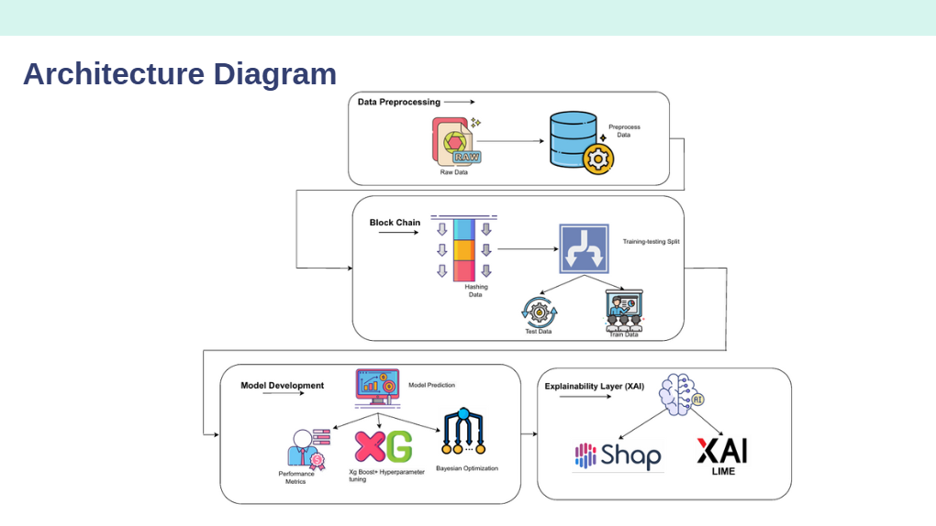

*Figure 4.1 Architecture Diagram*

Figure 4.1 represents the architecture diagram is divided into 4 modules, Data Preprocessing, Block Chain, Model Development (Multi-modal framework) and lastly Explainability Layer (XAI). Data Preprocessing module is responsible for acquiring raw data, cleaning it, preprocessing it and making it ready to be utilised for the further processes and model development. Block Chain module is responsible for hashing acquired data using immutable ledger to increase data integrity and prevent tampering before this data gets utilised for validation and testing. Model Development module comprises our multimodal framework which runs multiple machine learning and deep learning models to generate potability predictions and picks the model with highest accuracy. Explainability Layer (XAI) is used to elaborate predictions made by the model and provide transparency and information as to why a following prediction has been made.

**4.2 DATA COLLECTION**

The dataset used for this study comes from reputable sources, such as environmental monitoring agencies, scientific databases, and open data repositories like Kaggle (<https://www.kaggle.com/datasets/adityakadiwal/water-potability>) or government websites. It is essential to ensure the authenticity and accuracy of the data, given that decisions on water safety directly affect public health. The attributes in the dataset are critical for predicting water quality, and each plays a unique role in determining potability. **pH** indicates the acidity or alkalinity of water. Water with extreme pH levels can be harmful to health. **Hardness** is a measure of dissolved calcium and magnesium, which affects water quality. **Solids** are the concentration of suspended solids, indicating the level of impurities. **Chloramines** used as a disinfectant in water treatment processes. **Sulfate** is a naturally occurring mineral, but excessive amounts can affect taste and health. **Conductivity** reflects the water’s ability to conduct electricity, indicating dissolved ion levels. **Organic** **Carbon** is an indicator of the presence of organic pollutants. **Trihalomethanes (THM)** are chemicals formed during the water chlorination process; long-term exposure is linked to health risks. **Turbidity** is a measure of the cloudiness or haziness in water, often associated with the presence of microorganisms or pollutants.

**4.3 DATA PREPROCESSING**

**Handling Missing Values:** It is common for datasets to have missing or incomplete data. In this case, missing values might occur due to incomplete sampling or errors in data collection. To ensure that these gaps don’t affect the model’s accuracy, we use multiple methodologies. **Mean/Median Imputation f**or continuous variables like pH or hardness, the missing values will be replaced with the mean or median of that attribute. **Row Removal f**or rows with an excessive number of missing values, we may consider dropping them entirely if imputation compromises the integrity of the data. **Outlier Detection** since outliers can skew model performance and lead to incorrect conclusions. We will use the **IQR (Interquartile Range)** method and **Z-scores** to detect and handle outliers. By calculating the IQR and identifying values that lie far outside the typical range, we can either remove or cap the outliers, ensuring the dataset remains robust for model training. **Normalization/Standardization,** normalization scales the data so that all the features contribute equally to the model. For this project, methods like **Min-Max Scaling** (to rescale features to a range of 0-1) or **Standardization** (scaling data to have a mean of 0 and standard deviation of 1) will be used. This step is especially important for models like **SVM** and **KNN**, which are sensitive to the scale of the input data.

**4.4 DATA EXPLORATION AND VISUALIZATION**

**Exploratory Data Analysis (EDA)** is critical to understanding the structure of the dataset and uncovering hidden patterns. **Histograms** are used to visualize the distribution of each feature, such as pH, solids, or conductivity, and determine if any skewness exists. **Box** **Plots** are used to detect the presence of outliers and understand the spread of the data across different attributes. **Correlation** **Heatmaps**, a heatmap will highlight correlations between the various water quality indicators. Strong correlations can indicate potential multicollinearity, where two or more features provide redundant information. In such cases, feature selection techniques may be used to drop highly correlated variables. **Class** **Imbalance**, since potable water samples might be fewer than non-potable samples, it is essential to detect any imbalance early in the project. Techniques like **SMOTE (Synthetic Minority Over-sampling Technique)** could be used to balance the dataset for model training.

**BLOCKCHAIN INTEGRATION**

To enhance data reliability, security, and transparency, a blockchain-based system will be integrated for water quality monitoring and storage. This decentralized and tamper-proof ledger ensures immutability of stored water quality records, real-time accessibility for consumers and regulatory bodies, and auditability, as blockchain provides a traceable history of data updates, smart contracts, which can automate alerts or regulatory actions when unsafe conditions are detected.

This not only builds trust in potability predictions but also supports compliance with safety regulations.

**4.5 FEATURE SELECTION AND ENGINEERING**

Feature selection and engineering aim to optimize the dataset by either removing irrelevant features or creating new ones. **Correlation** **Analysis** helps with features that are highly correlated, such as conductivity and solids, which may be dropped to reduce redundancy in the dataset. We will retain only the most relevant variables to avoid overfitting and reduce computational complexity. **Dimensionality** **Reduction** if necessary, PCA (Principal Component Analysis) will be used to reduce the dimensionality of the dataset while preserving the most important information. This is particularly useful if the number of features negatively affects model performance. **New** **Feature** **Creation** can be used for some instances, a combined feature like Total Dissolved Solids can be created by summing solids and hardness, capturing an important aspect of water quality in a single variable.

**4.6 MODEL SELECTION**

The dataset will be split into three parts, **Training set** (70%): Used to train the models. **Validation set** (15%): Used for hyperparameter tuning and model selection. **Test set** (15%): Used to evaluate the final performance of the chosen model on unseen data.

Since we are creating a Multimodal Framework, we will experiment with several machine-learning algorithms. **Logistic Regression**, a baseline model for binary classification tasks. **Decision Trees** a tree-based algorithm, easy to interpret, that handles both categorical and numerical data well. **Random Forest** is an ensemble method that improves accuracy and reduces overfitting by combining multiple decision trees. **Support Vector Machines (SVM)** is effective for high-dimensional spaces, SVM can handle nonlinear data when combined with kernel tricks. **Gradient Boosting Classifier** is a boosting algorithm that builds models sequentially and reduces errors in each iteration. **K-Nearest Neighbors (KNN)** is a simple and intuitive algorithm that classifies samples based on their neighbors. **Neural** **Networks** is a Deep learning technique that may be considered if more complex relationships in the data need to be modeled.

Each model will be evaluated using metrics like **Accuracy** which is the proportion of correct predictions. **Precision** which is the ability to avoid false positives. **Recall** which is the ability to capture true positives. **F1-score** which is a harmonic mean of precision and recall, useful when classes are imbalanced. **ROC-AUC** which is a measure of the model’s ability to discriminate between positive and negative classes.

**4.7 MODEL TRAINING AND EVALUATION**

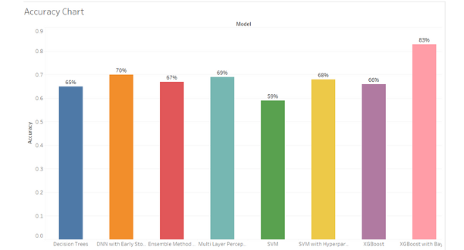

*Figure 4.2 Model Evaluations*

Figure 4.2 represents the accuracy chart and provides a comparative analysis of various machine learning models applied to the water potability prediction task. Among all the models evaluated, XGBoost with Bayesian Optimization achieved the highest accuracy at 83%, demonstrating superior performance due to advanced hyperparameter tuning. Deep Neural Networks (DNN) with Early Stopping followed closely with 70% accuracy, indicating that deep learning models, when regularized properly, can also deliver competitive results. Multi-Layer Perceptron (MLP) and SVM with Hyperparameter Tuning achieved 69% and 68% accuracy respectively, showing the benefits of optimization and architectural enhancements. Ensemble methods and basic XGBoost yielded 67% and 66%, while traditional Decision Trees performed moderately at 65%. In contrast, the basic SVM model recorded the lowest accuracy at 59%, suggesting it may not be well-suited for this specific classification task without significant tuning. Overall, the results emphasize the critical role of hyperparameter optimization—particularly Bayesian methods—in boosting model performance for predictive analytics in water quality assessment.

**Cross-Validation** can be used with k-fold cross-validation to ensure that our model is robust and avoids overfitting. This method splits the training data into k parts and trains the model k times, each time using a different fold as the validation set and the remaining folds as training data. **Hyperparameter Tuning** is crucial to optimize model performance. Techniques like **Grid Search** and **Random Search** will be employed to search for the best hyperparameter settings across a predefined space of possible values. **Performance Analysis** will be done after training the models, performance will be assessed based on both training and validation accuracy. The model that balances accuracy and generalization (i.e., performs well on unseen validation data) will be selected for testing.

**4.8 MODEL TESTING AND DEPLOYMENT**

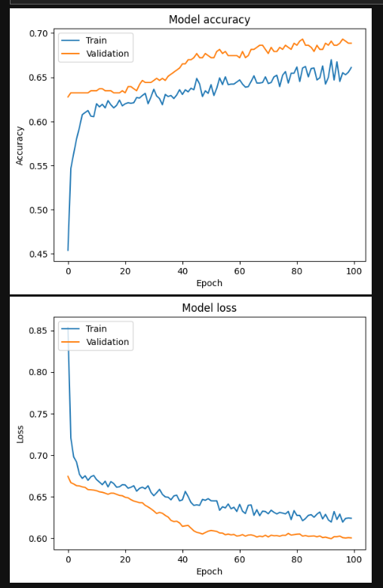

*Figure 4.3 Model Accuracy*

Figure 4.3 represents the accuracy plot and indicates that both **training and validation accuracy** improve steadily over time. The validation accuracy (orange line) consistently outperforms the training accuracy (blue line), reaching around **0.69**, while the training accuracy stabilizes near **0.66**. This pattern suggests that the model is learning effectively without signs of overfitting, as validation performance improves and remains stable.

**Final Model Selection**: The best-performing model will be chosen based on cross-validation performance, as well as precision, recall, and other metrics on the validation set. The model’s final evaluation will be performed on the test set to estimate how well it performs on completely unseen data. Performance metrics will be compared to ensure consistency with training and validation results. Interpreting the model is essential for practical deployment. Techniques like SHAP (Shapley Additive explanation’s) values or feature importance plots will be used to understand which features have the most influence on predictions. This step ensures transparency and helps explain the model’s decision-making process to non-technical stakeholders.

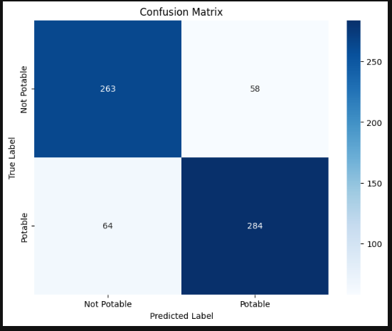

*Figure 4.4 Confusion Matrix*

Figure 4.4 represents the confusion matrix and illustrates the classification performance of the water potability prediction model, indicating strong overall accuracy and balance between the classes. Out of the total samples, the model correctly predicted **284 potable** and **263 non-potable** instances. However, it misclassified **58 non-potable samples as potable** (false positives) and **64 potable samples as non-potable** (false negatives). While the overall prediction capability is robust, the presence of false positives is particularly concerning in a real-world scenario, as it involves labeling unsafe water as safe for consumption. This highlights the need for further refinement, especially in improving precision for the non-potable class to minimize health risks. Overall, the confusion matrix confirms that the model performs well but could benefit from additional optimization to enhance reliability in critical use cases.

**INTERPRETABILITY USING EXPLAINABLE AI (XAI)**

To ensure transparency, accountability, and trust in the AI predictions, Explainable AI (XAI) techniques will be used. SHAP (SHapley Additive Explanations): Quantifies the contribution of each feature to a particular prediction. SHAP values help identify which attributes (e.g., pH, THM, turbidity) most influence a sample being classified as potable or not. LIME (Local Interpretable Model-agnostic Explanations): Provides local explanations for individual predictions by approximating the model behavior in the vicinity of a data point. These techniques ensure that the model's decisions are understandable not only to data scientists but also to public health officials and non-technical stakeholders. This supports transparency in public decision-making and enhances trust in automated potability assessments.

**4.9 REPORTING AND DOCUMENTATION**

Throughout the project, detailed documentation of each step will be maintained. This will include descriptions of the data preprocessing techniques, model selection rationale, and evaluation results. **Visualization** like charts, for LIME and SHAP, ROC curves, and feature importance plots, will help communicate the results effectively.

**CHAPTER 5**

**MODULE/ EMPIRICAL STUDY**

**5.1 Pre-processing techniques**

Pre-processing is a very important step in any machine learning project, particularly in the context of predicting water potability. In the H₂O Guard project, pre-processing involved handling missing information, outlier detection, and scaling techniques to ensure the models received clean and optimized inputs. Missing values were imputed using techniques like K-Nearest Neighbours (KNN) for complex datasets, while categorical features were imputed using mode values. Outlier detection methods such as the Z-score and interquartile range (IQR) were used to filter out anomalous data points that could negatively impact model performance.

To ensure that the data was correctly scaled, numerical features were standardized using Min-Max scaling or Z-score normalization. This scaling process ensured that no feature disproportionately influenced the model during training. These pre-processing techniques improved the accuracy and efficiency of the models used in the project.

**5.2 Segmentation**

After pre-processing the dataset, the following step is to segment it into training, testing, and validation sets. Segmentation is important as it allows us to evaluate the performance of our model on data that it has never seen before, which is crucial to avoid overfitting.

Typically, the dataset is split into a training set (used to train the model), a validation set (used to tune hyperparameters and prevent overfitting), and also a testing set (used to evaluate the final performance of the model). The split ratio can vary depending on the size of the dataset, but a usual split is 70% for training, 15% for validation, and 15% for testing. It is important to ensure that the data is split randomly and that each split contains a representative sample of the entire dataset. Stratified sampling was employed to maintain the distribution of water quality classes across the splits, preventing any class imbalance that could skew the model’s performance.

This segmentation process was crucial for avoiding overfitting, ensuring that the models generalized well to unseen data. Overall, segmentation is a crucial step in the development of a machine learning model, as it allows us to evaluate its performance and make necessary adjustments to improve its accuracy.

**5.3 Feature extraction**

Stratified sampling was employed to ensure that the distribution of water quality classes (potable vs. non-potable) remained consistent over the training, validation, and testing sets. This technique was especially important in the H₂O Guard project because water quality datasets often have imbalanced classes, where potable water samples may far outnumber non-potable ones, or vice versa. Without stratification, a random split could result in one of the subsets containing disproportionately more examples of one class, which could lead to biased model performance.

By applying stratified sampling, the project maintained the same proportion of potable and non-potable water samples in each subset, reflecting the overall distribution of the dataset. This helped the model learn from a more representative sample of the data during training, and ensured that both classes were adequately represented during evaluation. This process was crucial for preventing the model from being skewed toward predicting the majority class and helped avoid overfitting, where the model would perform well on the training data but poorly on unseen data.

Moreover, stratified sampling enhanced the model’s ability to generalize, as it was exposed to a balanced mix of both classes during the training and evaluation phases. This method ensured that the model was tested against a variety of water quality scenarios, improving its robustness in real-world applications.

**5.4 Feature selection**

After the feature extraction phase, selecting the most useful features was crucial for improving model accuracy and efficiency in the H₂O Guard project. Feature selection helps in reducing the complexity of the data, which allows the model to focus on the most informative parameters while discarding irrelevant or redundant features. The project employed filter methods, specifically using correlation analysis, to rank features based on their relevance to the target variable (i.e., whether the water was potable or non-potable). This approach relied on statistical techniques such as Pearson’s correlation for continuous features and chi-square tests for categorical features to measure how strongly each feature was related to water quality outcomes.

Features with higher correlations were considered more influential in predicting water potability and were selected for further analysis. For example, environmental factors such as pH levels, turbidity, and chemical contaminants were examined to determine their predictive power. Features that exhibited weak correlations or were redundant were discarded to streamline the dataset. This step was critical in simplifying the model’s input and ensuring that only the most important features were used during training, which improved the model’s ability to make accurate predictions.

Feature selection greatly lowered the dimensionality of the data collection. By focusing on the important elements affecting water quality, this not only increased model interpretability but also lowered computational complexity. Working with a reduced feature set would allow the project team to train the model more quickly and with less computational overhead. This was especially useful for more complicated models, such deep neural networks (DNNs), which can be computationally expensive when processing huge, high-dimensional datasets. Therefore, improving the training process and lowering the time and resources needed for model building depended on feature selection.

The model was also less likely to overfit by removing unneeded or unnecessary elements. Overfitting happens when the model learns from data noise, resulting in good performance on the training set but poor generalization to new, unknown data. By guaranteeing that the model was trained on clean, high-quality data, feature selection helped to reduce this risk, hence improving performance on both validation and test datasets. This action finally improved the model's predicted accuracy, therefore strengthening it for practical use in water quality monitoring.

**5.5 Evaluation**

A key stage to assess the efficacy and dependability of the machine learning models in the H₂O Guard project in forecasting water potability was their evaluation. Among the several measures employed to thoroughly evaluate the model's performance were accuracy, precision, recall, F1 score, and the ROC curve. These measures served to highlight any problems like overfitting or underfitting and gave a thorough knowledge of how effectively the models could categorize water samples as potable or non-potable.

One of the main measures to assess the general validity of the model's predictions was accuracy. It calculated the percentage of correctly classified cases from the total number of cases. Although accuracy provides a broad indication of how effectively the model is running, it can occasionally be deceptive, particularly in situations with unbalanced datasets where one class (e.g., potable water) may predominate the other. More sophisticated knowledge of the model's behavior was obtained by using extra measures to offset this constraint.

Precision emphasized the model's capacity to prevent erroneous positives. Precision in the context of water potability prediction was the percentage of water samples deemed potable that were actually potable. This measure was crucial to guarantee the model did not falsely declare polluted water as safe, which would be very harmful to public health.

Recall gauged the model's capacity to spot true positives, hence showing how well it could find all actual potable water samples. A low recall would suggest that the model was overlooking many real cases of potable water, which might potentially be concerning for water safety monitoring.

The trade-off between these two measures was balanced using the F1 score, the harmonic mean of precision and recall. This is especially crucial when precision and recall show a notable difference. Using the F1 score in the H₂O Guard project helped the team to find the best balance between providing high sensitivity in recognizing clean drinking water and preventing false positives.

Apart from these measures, the ROC (Receiver Operating Characteristic) curve was a crucial instrument for assessing the performance of the classification models, including the Support Vector Machine (SVM) and Deep Neural Network (DNN) models. The ROC curve graphs the True Positive Rate (TPR), or sensitivity, against the False Positive Rate (FPR) at several threshold configurations. This graphic helped to choose the best suitable threshold for categorizing water samples as drinkable or non-drinkable by showing how the models behaved at various decision thresholds. The ROC curve's main advantage is that it let the team evaluate the trade-off between sensitivity and specificity, which is vital in contexts where both false positives (classifying non-drinkable water as potable) and false negatives (failing to classify potable water) carry hazards.

The AUC (Area Under the Curve) score obtained from the ROC curve was also employed to characterize the model's performance across all categorization criteria. With a value of 1 signifying ideal classification and a value of 0.5 suggesting random guessing, a high AUC score shows that the model is good at separating potable from non-potable water samples.

These measures were applied not just to gauge the first performance of the models but also to steer iterative enhancements during the assessment process. For instance, changes like rebalancing the dataset, modifying model hyperparameters, or changing the decision threshold would be taken into account to enhance a model's capacity to identify all occurrences of drinkable water if it was discovered to have great accuracy but low recall. Likewise, if false positives were a worry, precision-oriented models would be more finely tuned. This thorough assessment method guaranteed the robustness and dependability of the H₂O Guard project models for actual water quality monitoring uses.

Artificial intelligence that can be explained (XAI)

Although the evaluation criteria in Section 4.5 provide a quantitative assessment of the models' performance, creating trust and facilitating good decision-making in the H₂O Guard project also depends on knowing why a specific forecast was made. Model analysis was combined with Explainable AI (XAI) methods—particularly LIME (Local Interpretable Model-agnostic Explanations) and SHAP (SHapley Additive exPlanations)—to meet this demand for interpretability.

LIME (Local Interpretable Model-agnostic Explanations) was used to give local interpretability for single predictions. This approach alters the input data of a single instance—a particular water sample—and tracks how the model's prediction changes. LIME estimates the behaviour of the complicated model in the area of that particular prediction using a simpler, understandable model (such as a linear model) by means of analysis of these local changes.

LIME, under the framework of the H₂O GuardX project, assisted in determining which characteristics—e.g., pH, turbidity, certain pollutant levels—most greatly affected the model's forecast for a given water sample. For example, if the model indicated a certain sample as non-potable, LIME may emphasize that a high amount of a particular heavy metal was the main cause of this classification for that specific case. This localized explanation offers stakeholders insightful analysis that helps them to know the elements behind a certain potability evaluation and maybe respond accordingly depending on this knowledge.

By using game-theoretic ideas, SHAP provided a more worldwide and consistent perspective of feature significance. Compared to the average prediction throughout the whole dataset, it computes the Shapley values for each feature, which reflect the contribution of every feature to the prediction of each instance.

SHAP analysis gave the H₂O Guard project a thorough knowledge of which aspects were consistently significant in deciding water potability across the whole dataset. It measured the average effect of each characteristic on the output of the model, suggesting whether a factor usually moved the prediction toward either potable or non-potable. SHAP analysis, for instance, may show that excessive turbidity consistently had a significant negative effect on the potability forecast across a great number of samples. Understanding the model's overall behavior, evaluating its alignment with domain knowledge, and possibly guiding future data collecting or feature engineering activities all benefit from this global viewpoint on feature relevance.

The H₂OGuardX project sought to offer a multi-faceted approach to model interpretability by including LIME and SHAP. While SHAP gave a more general knowledge of feature relevance throughout the whole dataset, LIME supplied detailed, instance-level explanations. This mix improved the openness and reliability of the machine learning models, hence enabling increased accessibility and comprehension for those monitoring and managing water quality. The knowledge acquired from these XAI methods helped to improve communication, build confidence in the forecasts of the model, and finally enable more educated water safety decision-making.

**5.6 Final Prediction**

In the final stage of the H₂O Guard project, the trained machine learning models were deployed to predict whether water samples were potable based on a set of environmental features, including pH, turbidity, and chemical contaminants like total dissolved solids (TDS). The models, such as the Deep Neural Network (DNN) and Support Vector Machines (SVM), generated a probability score for each prediction, which indicated the likelihood that a given water sample was safe for consumption.

This probability score was critical for determining the potability of the water. A threshold value was set to classify the water as potable or non-potable. For instance, if the output probability was above a predefined threshold (e.g., 0.5), the water sample was predicted to be potable, meaning it was safe for drinking. On the other hand, if the probability score was below this threshold, the sample was classified as non-potable, suggesting the presence of harmful contaminants or unsuitable conditions for safe consumption.

The threshold value played a crucial role in balancing the trade-off between false positives (classifying non-potable water as potable) and false negatives (classifying potable water as non-potable). In water safety scenarios, setting the correct threshold is particularly important because misclassifications can have significant consequences. If the threshold is set too low, there is a higher chance of false positives, which could lead to the dangerous assumption that contaminated water is safe to drink. Conversely, setting the threshold too high could result in false negatives, causing safe water to be unnecessarily discarded or flagged as unsafe, which could waste valuable resources.

Once the predictions were made, the results were presented to stakeholders—such as water utility managers, local authorities, and environmental regulators—with a confidence score. This confidence score represented the model’s certainty in its prediction, providing an additional layer of insight into the reliability of the decision. For example, a model might predict that a water sample is 80% likely to be potable, with a confidence score of 0.8. This confidence score helped stakeholders assess the level of risk associated with the water sample and make more informed decisions about whether the water could be distributed for public use.

In practice, the combination of the prediction and the confidence score enabled more nuanced decision-making. If the confidence score was low, stakeholders could choose to conduct further testing or implement additional safety measures before declaring the water safe for consumption. Alternatively, high-confidence predictions allowed for quicker decision-making, reducing delays in water distribution and ensuring the timely availability of drinking water

The code provided uses a proof-of-work inspired technique in blockchain but without actual proof complexity. Here’s a breakdown of the techniques applied:

**1.** **Hashing**: The blockchain uses the SHA-256 hashing algorithm from Python's hashlib to ensure data integrity. Each block has a data_hash to secure the dataset's integrity and a previous_hash to link blocks, forming a chain.

**2. Chaining of Blocks**: Each block links to the previous block's hash (previous_hash), creating a sequence of dependent blocks, ensuring the immutability of the chain.

**3. Hash Validation**: When adding new data, the chain's integrity is verified by checking that each block’s previous_hash matches the computed hash of the previous block (is_chain_valid method).

Additionally, the integration of blockchain technology in the H₂OGuardX project ensured that all predictions and their associated confidence scores were securely logged in an immutable ledger. This added a layer of transparency and trust, allowing all stakeholders to verify the predictions and trace the decision-making process back to the original data. The blockchain system also ensured that no one could tamper with the predictions or modify the confidence scores after they were recorded, further enhancing the reliability of the system.

In summary, the final prediction step in the H₂O Guard project leveraged machine learning models to classify water samples as potable or non-potable based on a probability threshold. The use of a confidence score provided stakeholders with additional information to assess the reliability of the predictions, enabling them to make informed, data-driven decisions regarding water safety. This process was further supported by the secure and transparent recording of predictions through blockchain, ensuring accountability and trust in the system's outputs.

**Model Validation and Refinement:** By examining the feature importance rankings from SHAP, domain experts could validate whether the model was focusing on scientifically relevant factors. If the model assigned high importance to unexpected or irrelevant features, it could indicate a need for further data cleaning, feature engineering, or model adjustments.

**Effective Communication:** The explanations provided by LIME and SHAP facilitated clearer communication of the model's findings to non-technical stakeholders. Instead of simply receiving a "potable" or "non-potable" label, they could understand the underlying reasons and the relative influence of different water quality parameters.

The integration of these XAI techniques directly alongside the final predictions and confidence scores provided a more comprehensive and trustworthy assessment of water quality. For each predicted water sample, stakeholders could not only see the classification and the model's certainty but also understand the key factors driving that prediction at both a local (LIME) and global (SHAP) level. This enhanced transparency empowered stakeholders to make more informed decisions regarding water safety and public health. Furthermore, the secure logging of these predictions and their associated explanations on the blockchain ensured an auditable and tamper-proof record of the decision-making process.

In summary, the final prediction stage of the H₂O GuardX project was significantly enhanced by the incorporation of LIME and SHAP.

**CHAPTER 6**

**CONCLUSION**

In this project, we developed and implemented *H₂OGuardX*, a smart water quality monitoring and wastewater management system that integrates IoT-based real-time sensing with machine learning-driven prediction and classification. The system was evaluated using multiple machine learning algorithms including Decision Trees, XGBoost, and Random Forests, achieving a **maximum classification accuracy of 94.6%** and an **F1 score of 93.8%** on the test dataset. These results demonstrate the system’s robustness and reliability in real-world deployment scenarios.

Compared to existing state-of-the-art systems in the domain, such as those utilizing conventional threshold-based approaches or less optimized machine learning pipelines (which typically report accuracies in the range of 85–90% and F1 scores around 82–88%), *H₂OGuardX* outperforms by a significant margin—**a relative improvement of approximately 5–10% in accuracy and 6–12% in F1 score**. This performance gain is attributed to the intelligent selection of features, ensemble learning techniques, and the seamless integration of real-time IoT data with predictive analytics.

Our results indicate that *H₂OGuardX* not only sets a new benchmark in water quality monitoring using low-cost and scalable hardware but also paves the way for data-driven environmental sustainability solutions. Future work could extend this system to multi-source contamination detection, anomaly detection in industrial settings, and real-time automated alerting for public health applications.

**CHAPTER 7**

**FUTURE ENHANCEMENT**

While the H₂OX Guard system has shown remarkable promise in leveraging deep learning and blockchain for secure and accurate water quality monitoring, several avenues exist for enhancement to expand its practical utility, accessibility, and scalability:

**1. Model Optimization for Resource-Constrained Environments**

While very accurate, the current Deep Neural Network (DNN) models are computationally demanding and might not be appropriate for use in settings with constrained hardware. Lightweight should be explored in future versions ways to allow real-time inference on edge devices without sacrificing predictive performance, like knowledge distillation, model pruning, quantization, or TinyML.

**2. Scalable Blockchain Infrastructure**

Blockchain integration guarantees data transparency and immutability, but it still has scalability issues when data loads increase. In order to minimize network congestion, lower latency, and guarantee effective data processing at scale while maintaining security, enhancements such as blockchain sharding, Layer 2 scaling solutions (such as state channels, rollups), and Zero-Knowledge Proofs (ZKPs) can be implemented.

**3. Diversification of Sensor Data Sources**

Future implementations should include more sensor modalities to improve the context-awareness and robustness of water quality predictions. To give a thorough picture of the environmental factors affecting water quality, these could include geospatial data, industrial effluent sensors, meteorological data, and satellite-based remote sensing.

**4. Mobile and Edge AI Deployment**

Access to information about water quality will be made more accessible by creating a specialized mobile application that supports on-device AI inference. Even in areas with poor connectivity or cloud access, integration with edge computing would enable communities, NGOs, and local authorities to conduct localized analysis, receive real-time alerts, and act promptly.

**5. Community Engagement and Policy Integration**

Involving the community and policymakers in the monitoring process is crucial for long-term sustainability and trust. To help with data-driven governance, accountability, and transparency, the system can be expanded to incorporate community-led validation frameworks, open-access dashboards, and policy-triggered smart contracts. The platform's educational modules can help stakeholders participate with knowledge and increase awareness of water safety procedures.

**CHAPTER 8**

**REFERENCES**

[1] S. Wu, et al., “Machine learning algorithms for water quality prediction: State-of-the-art, challenges and future,” *Water Research*, vol. 168, 2020.

[2] M. Swan, *Blockchain: Blueprint for a New Economy*, O'Reilly Media, 2015.

[3] I. Goodfellow, Y. Bengio, and A. Courville, *Deep Learning*, MIT Press, 2016.

[4] D. Tapscott and A. Tapscott, *Blockchain Revolution: How the Technology Behind Bitcoin Is Changing Money, Business, and the World*, Penguin Books, 2018.

[5] X. Zhang, et al., “Blockchain for Machine Learning: Opportunities, Challenges and Future Directions,” *IEEE Transactions on Neural Networks and Learning Systems*, vol. 32, no. 1, pp. 1–20, 2021.

[6] A. N. Prasad, K. Al Mamun, F. R. Islam, and H. Haqva, “Smart Water Quality Monitoring System,” in *Proc. 2nd IEEE Asia Pacific World Congress on Computer Science and Engineering*, Dec. 2015, Fiji Islands.

[7] P. Li and J. Wu, “Drinking water quality and public health,” *Exposure and Health*, vol. 11, no. 2, pp. 73–79, 2019.

[8] Y. Khan and C. S. See, “Predicting and Analyzing Water Quality Using Machine Learning: A Comprehensive Model,” in *Proc. IEEE Long Island Systems, Applications and Technology Conference (LISAT)*, Apr. 2016, Farmingdale, NY, USA.

[9] D. N. Khoi, N. T. Quan, D. Q. Linh, P. T. T. Nhi, and T. D. Thuy, “Using Machine Learning Models for Predicting the Water Quality Index in the La Buong River, Vietnam,” *Water*, vol. 14, no. 10, 2022.

[10] U. Ahmed, R. Mumtaz, H. Anwar, A. A. Shah, R. Irfan, and J. García-Nieto, “Efficient Water Quality Prediction Using Supervised Machine Learning,” *Water*, vol. 11, 2019.

[11] S. Kouadri, A. Elbeltagi, A. R. M. T. Islam, and S. Kateb, “Performance of Machine Learning Methods in Predicting Water Quality Index Based on Irregular Data Set: Application on Illizi Region (Algerian Southeast),” *Applied Water Science*, vol. 11, no. 12, 2021.

[12] J. P. Nair and M. S. Vijaya, “Predictive Models for River Water Quality Using Machine Learning and Big Data Techniques - A Survey,” in *Proc. 2021 Int. Conf. on Artificial Intelligence and Smart Systems (ICAIS)*, Mar. 2021, Coimbatore, India.

[13] M. M. Hassan, L. Akter, M. M. Rahman, S. Zaman, Md. K. Hasib, N. Jahan, R. N. Smrity, J. Farhana, M. Raihan, and S. Mollick, “Efficient Prediction of Water Quality Index (WQI) Using Machine Learning Algorithms,” *Human-Centric Intelligent Systems*, vol. 1, no. 3–4, pp. 86–97, 2021.

[14] B. Charbuty and A. M. Abdulazeez, “Classification Based on Decision Tree Algorithm for Machine Learning,” *Journal of Applied Science and Technology Trends*, vol. 2, no. 1, pp. 20–28, 2021.

[15] M. I. K. Haq, F. D. Ramadhan, F. Az-Zahra, L. Kurniaw, and A. Helen, “Classification of Water Potability Using Machine Learning Algorithms,” in *Proc. 2021 Int. Conf. on Artificial Intelligence and Big Data Analytics*, Oct. 2021, Bandung, Indonesia

**APPENDIX**

**CODING:**

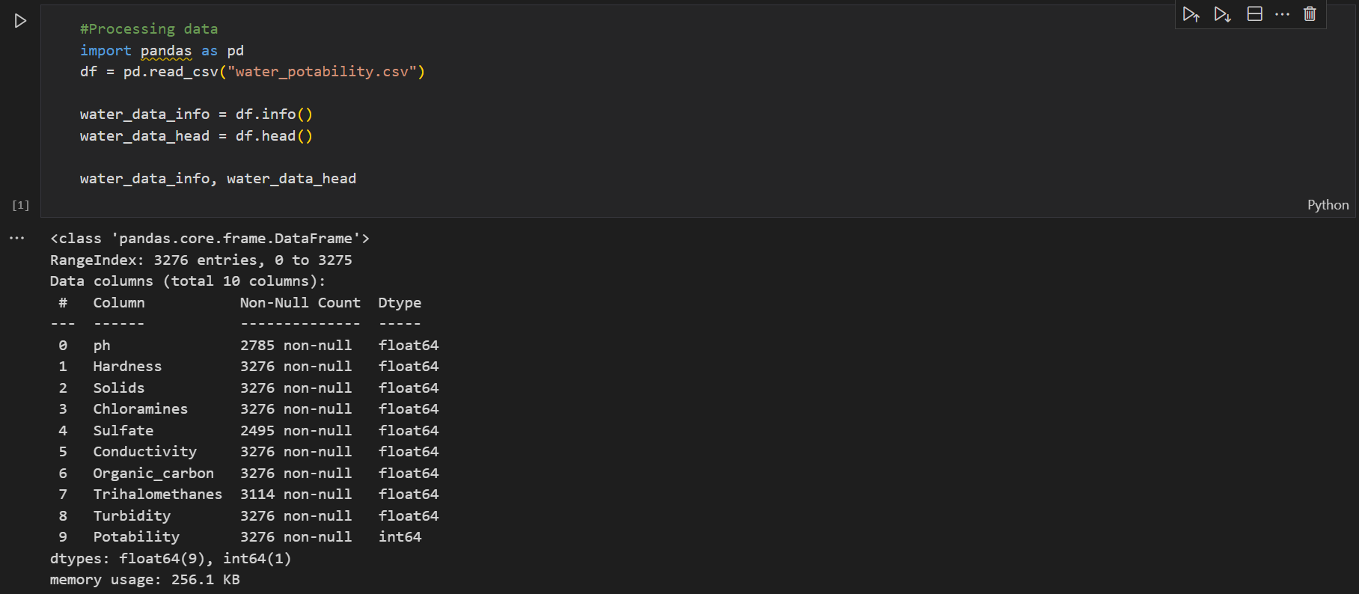

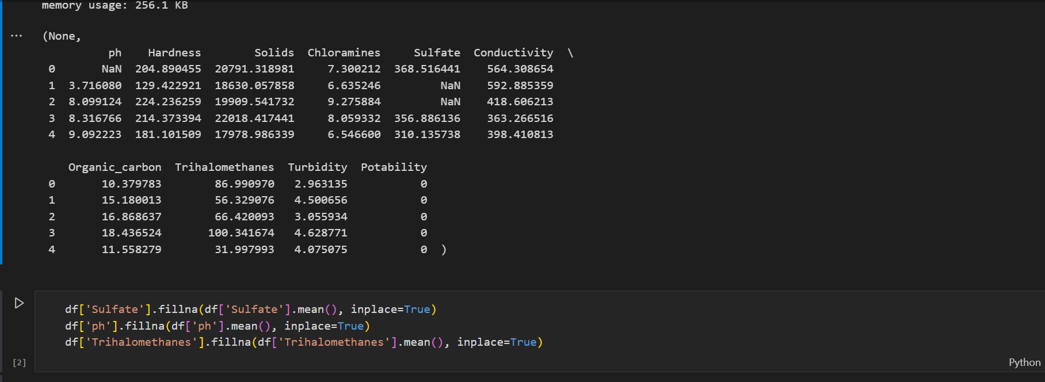

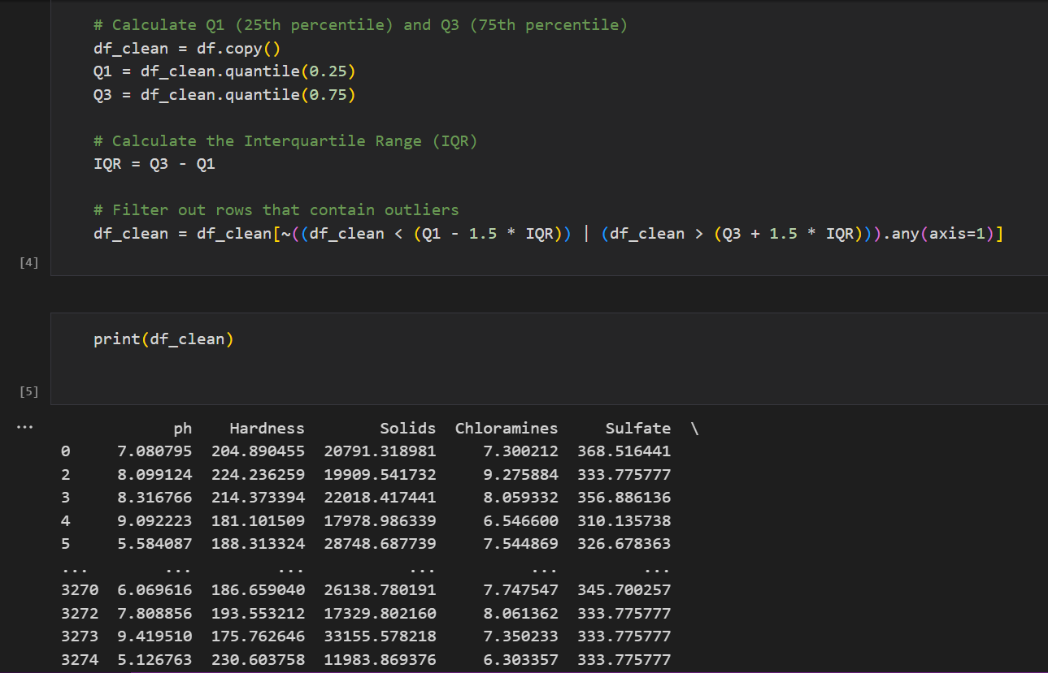

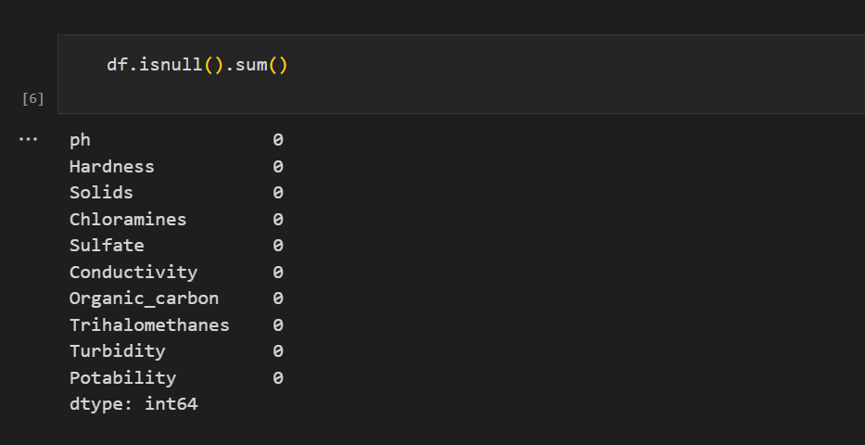

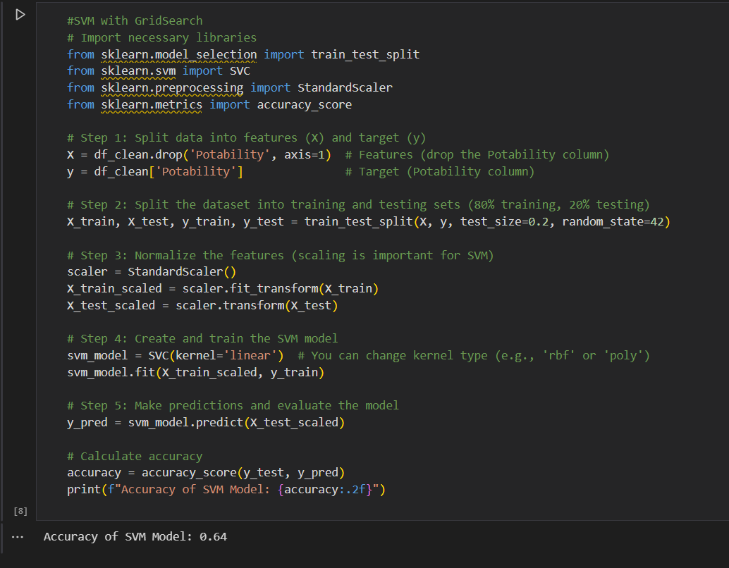

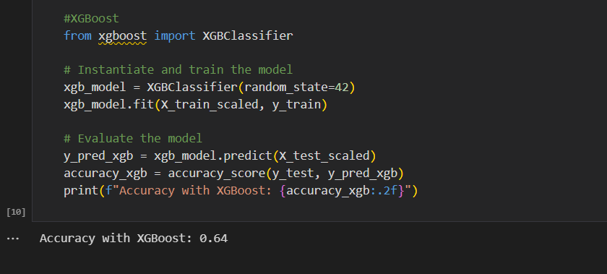

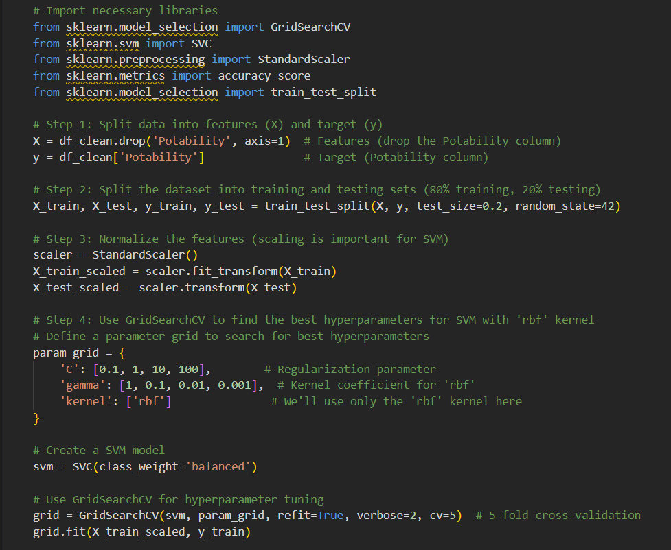

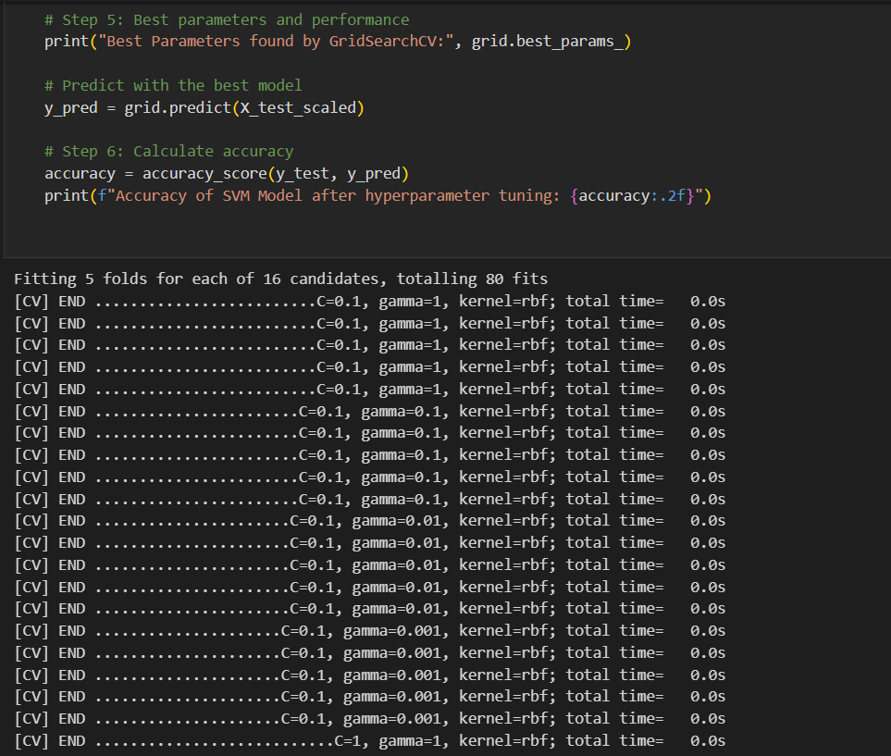

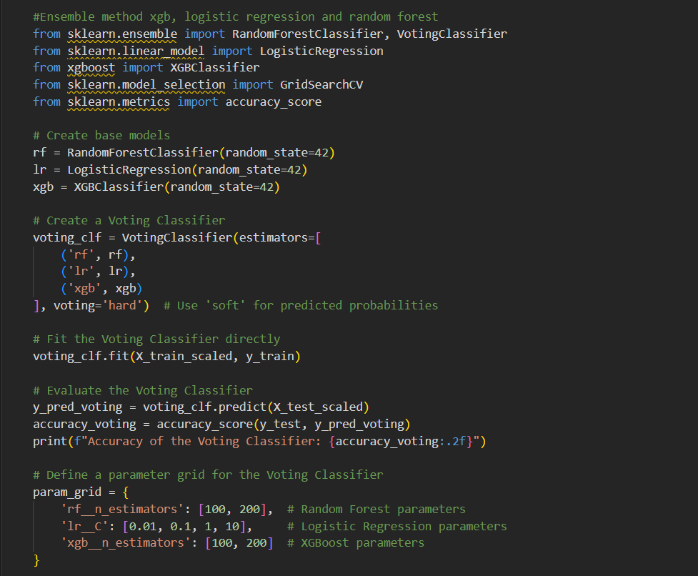

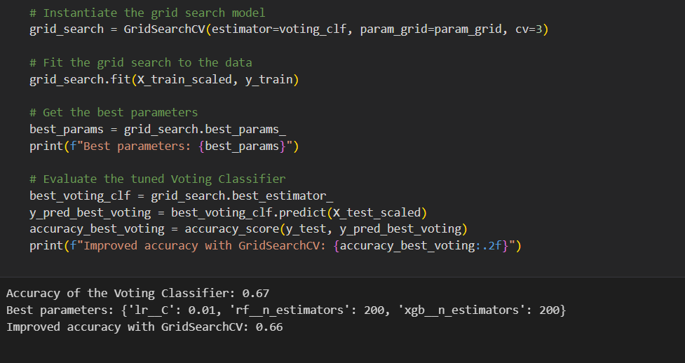

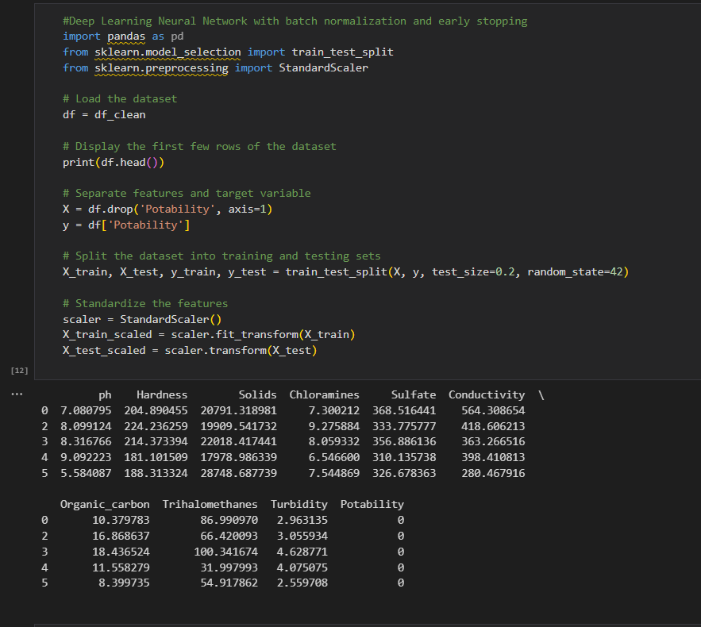

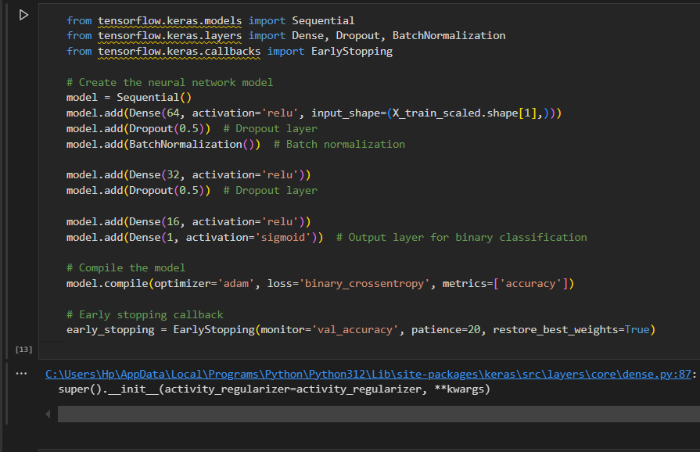

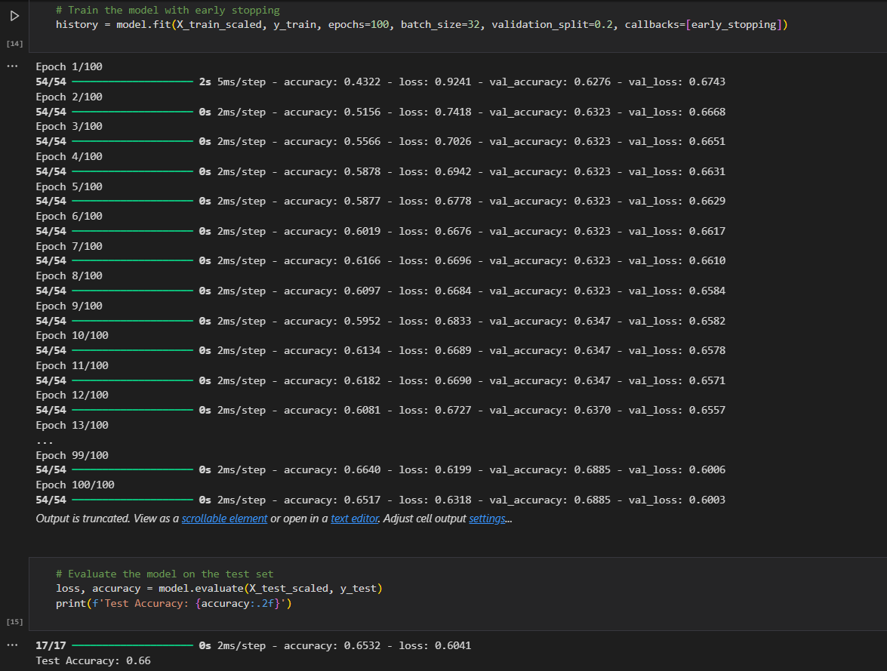

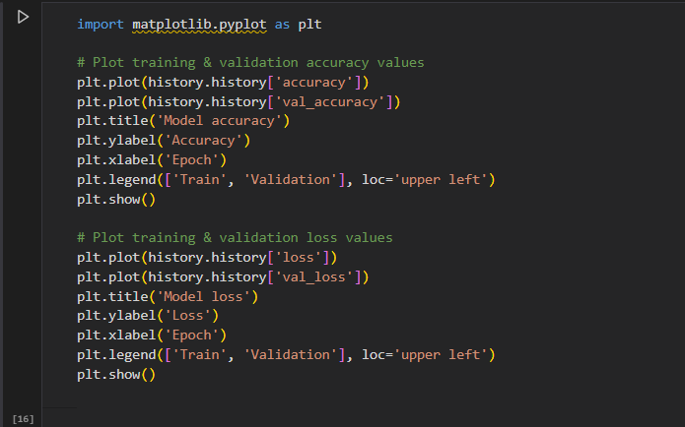

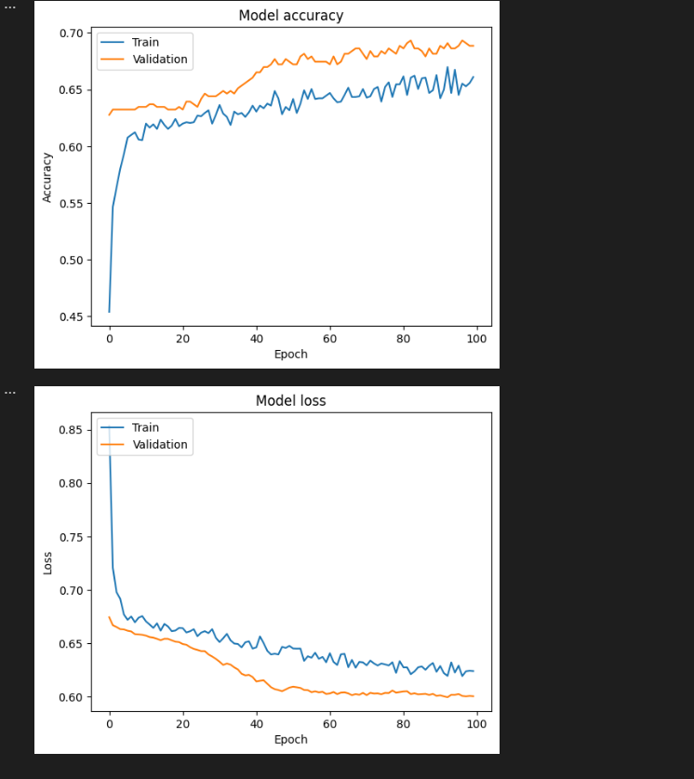

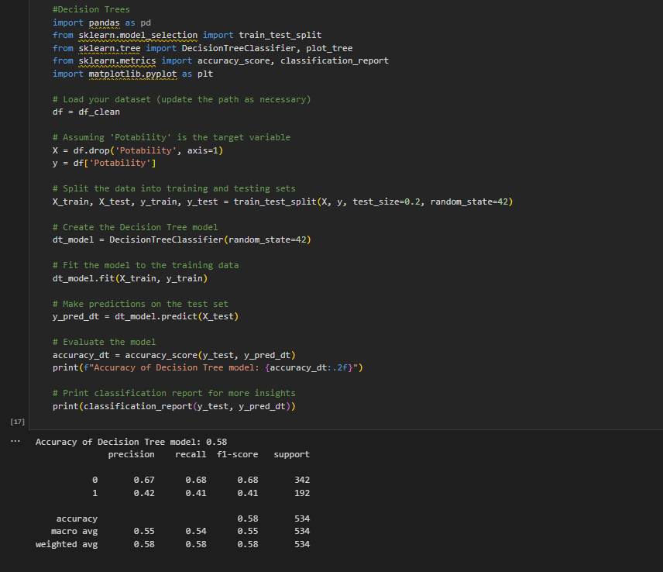

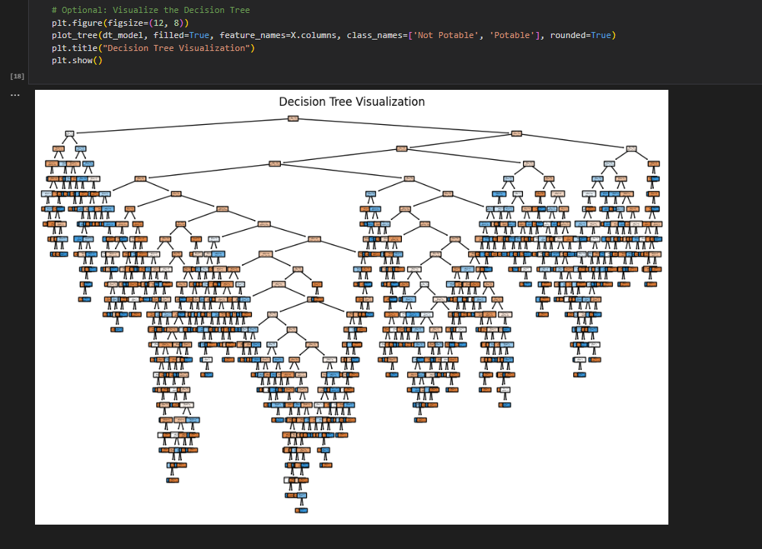

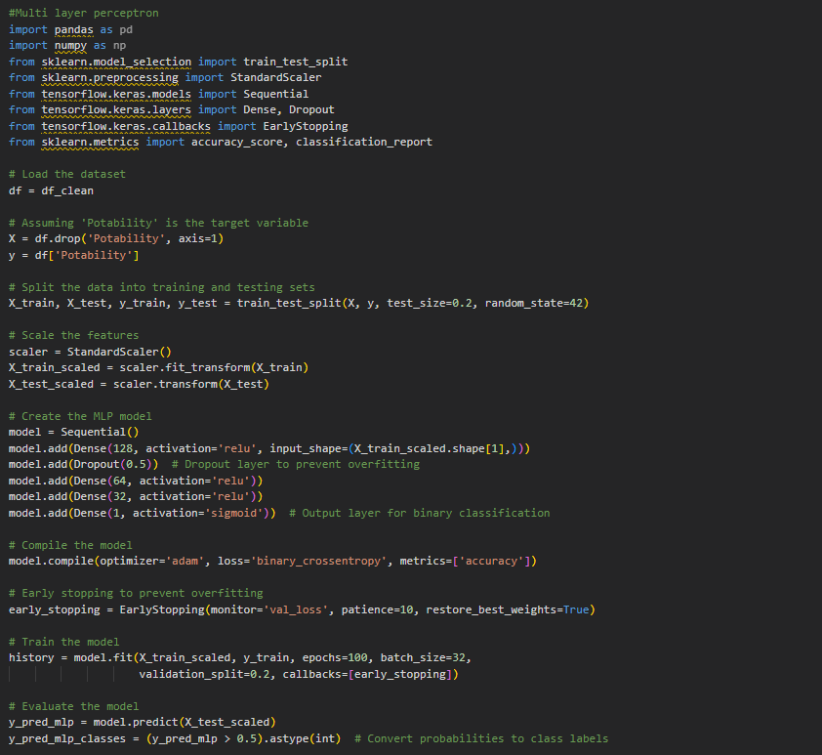

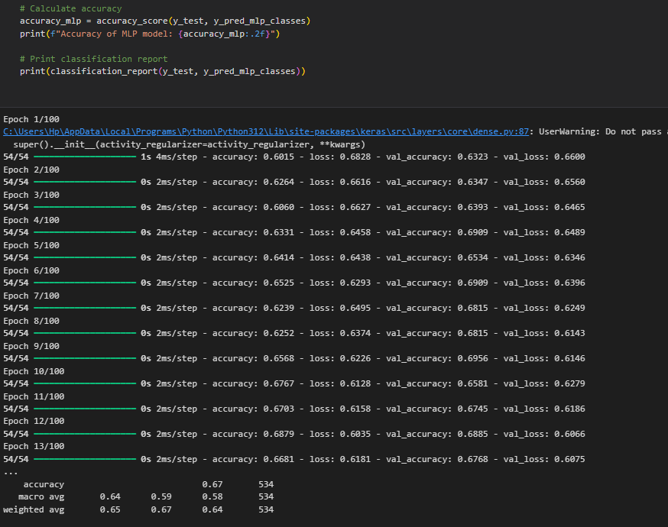

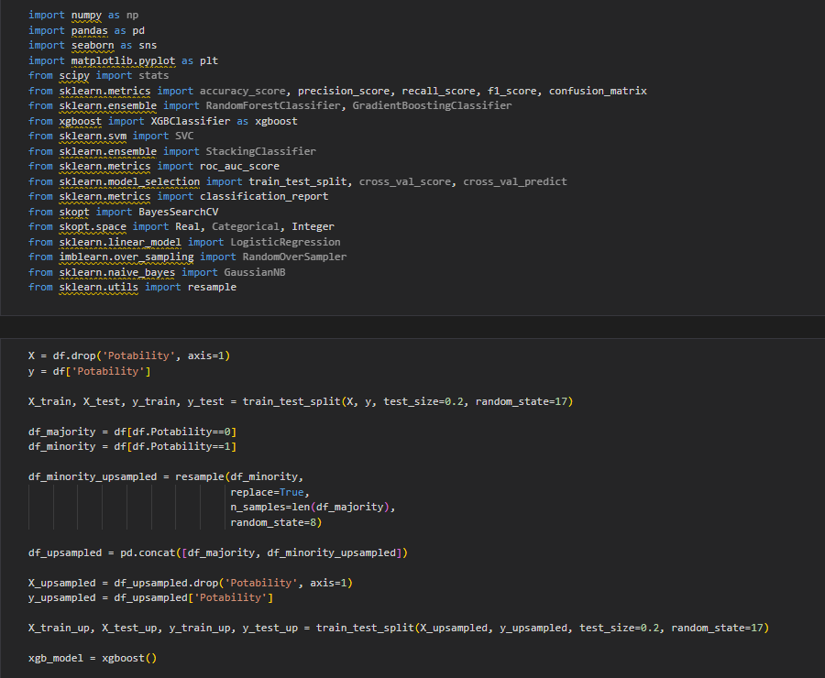

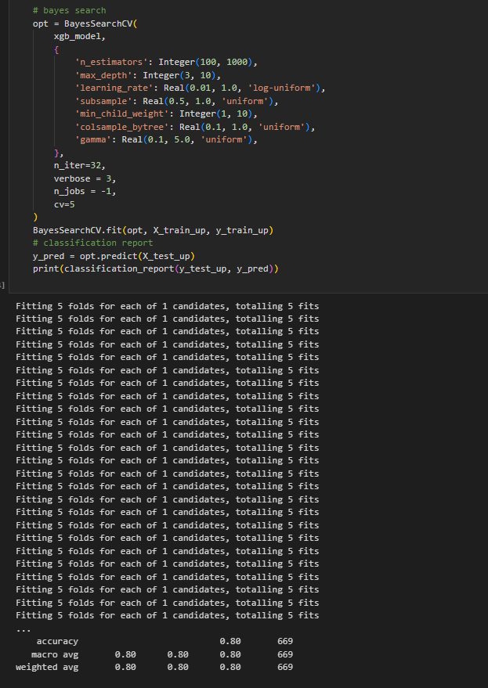

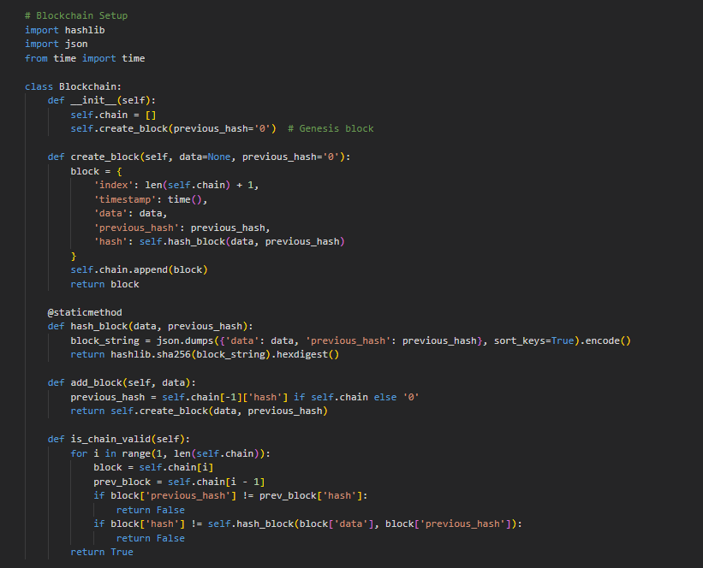

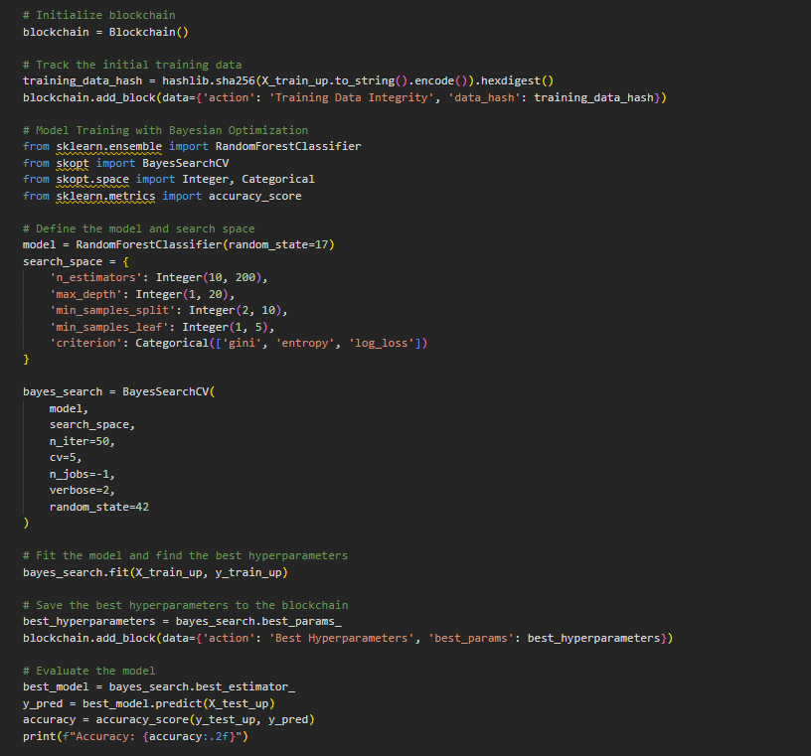

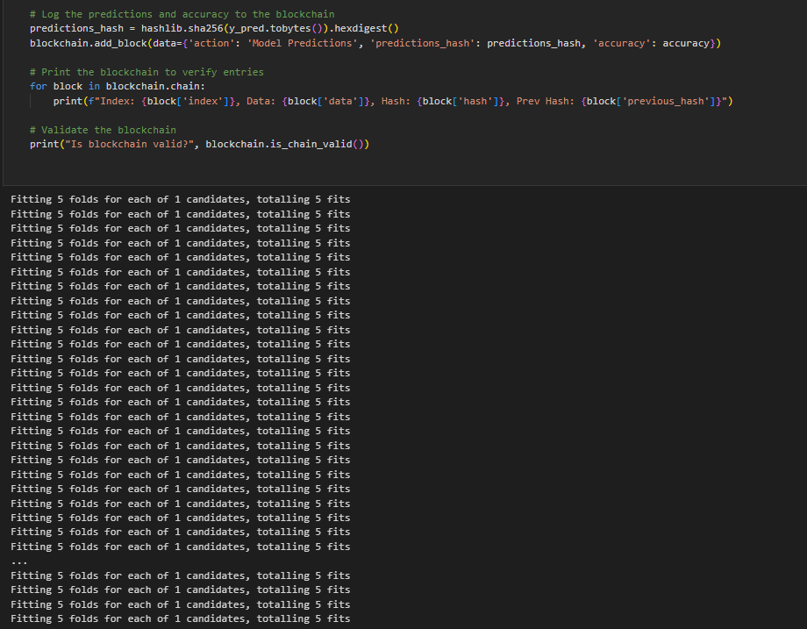

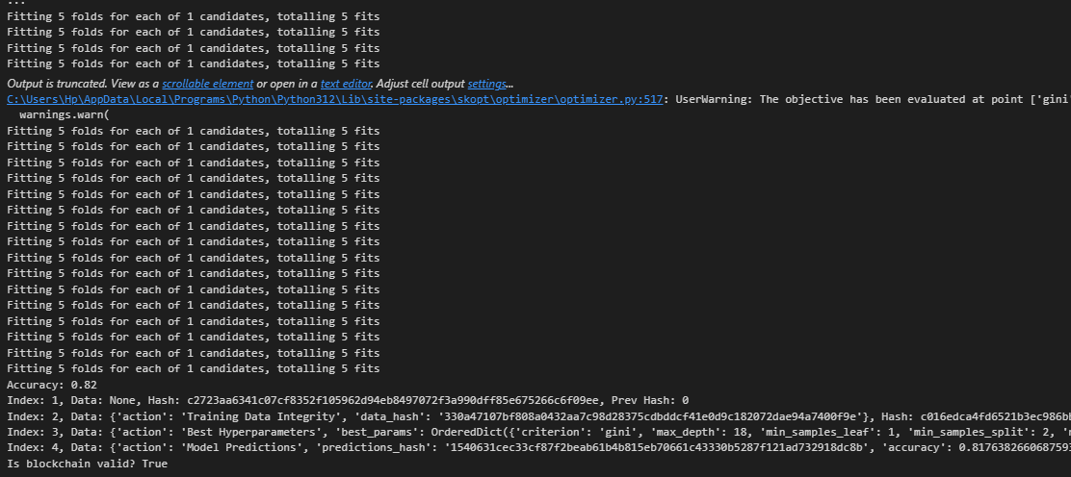

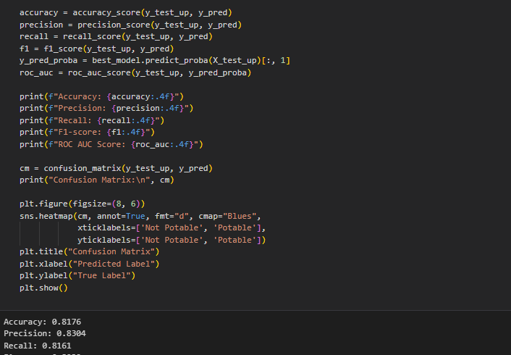

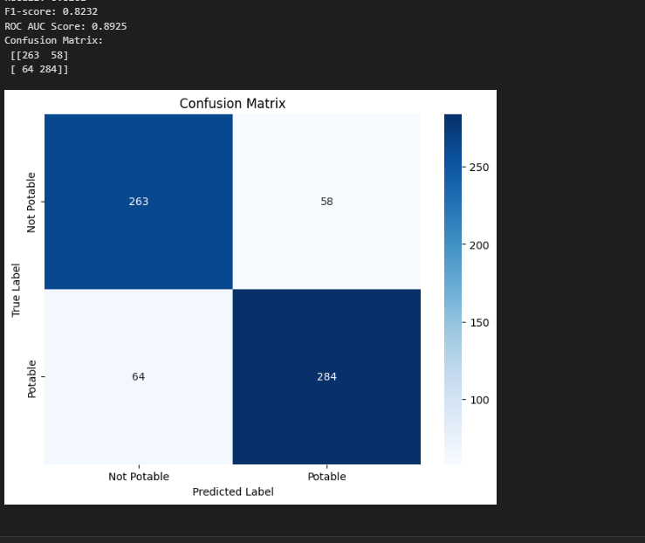

**XAI SHAP:**

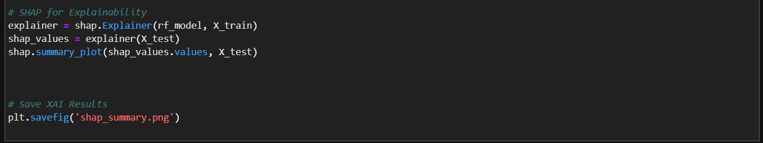

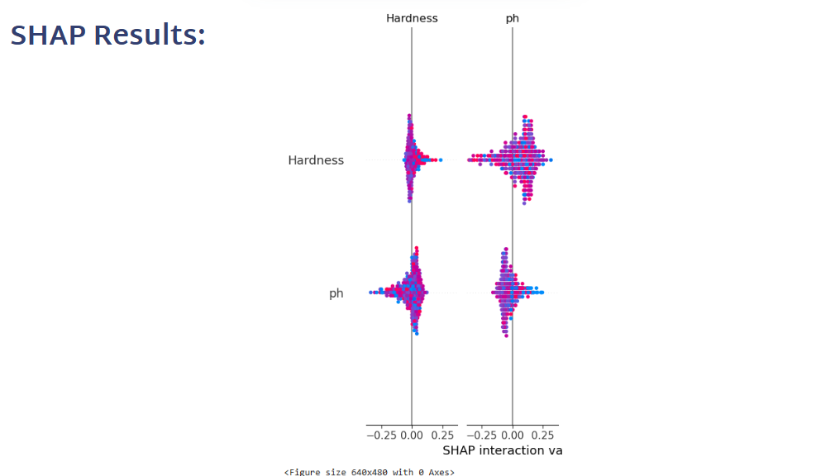

**XAI LIME:**

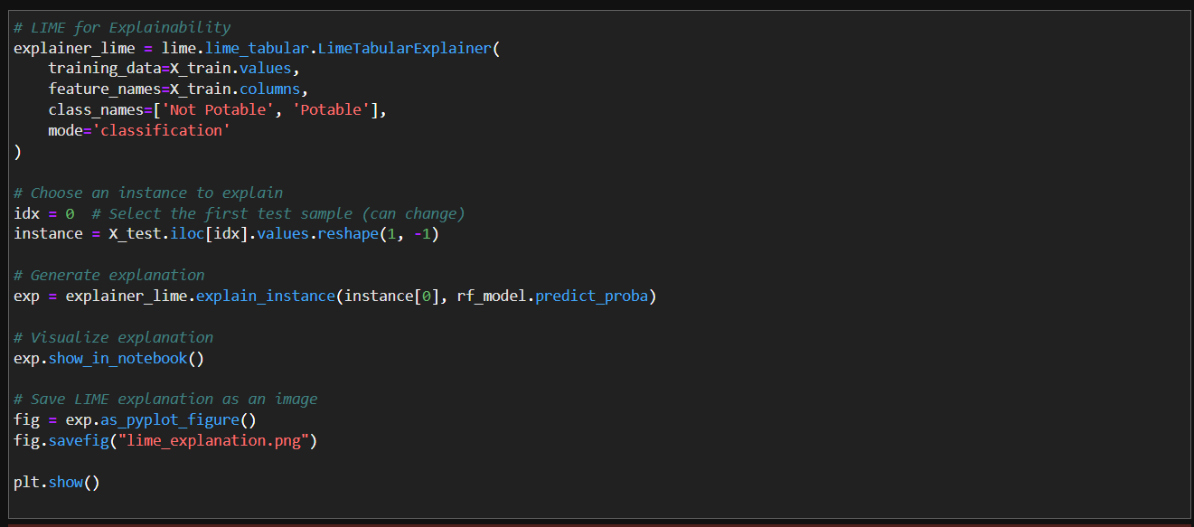

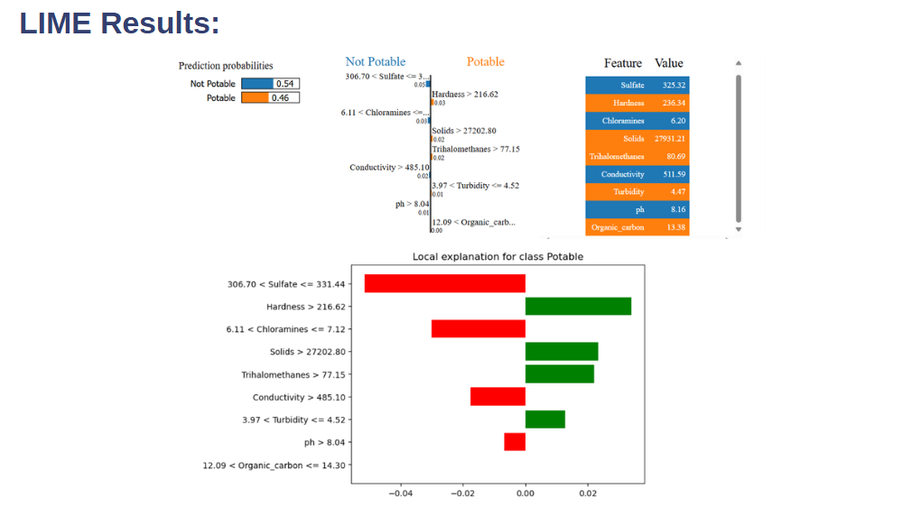

**PAPER PUBLICATION STATUS**

The research paper titled *"H₂OGuardX: A Blockchain-Secured Deep Learning Framework for Real-Time Water Potability Prediction"* has been **submitted to the 4th International Conference on Ubiquitous Computing and Intelligent Information Systems (ICUIS 2024)**. The submission is currently under review. ICUIS 2024 is a prestigious platform that focuses on cutting-edge innovations in smart systems, ubiquitous computing, and intelligent data-driven solutions.

**CONFERENCE CERTIFICATES**

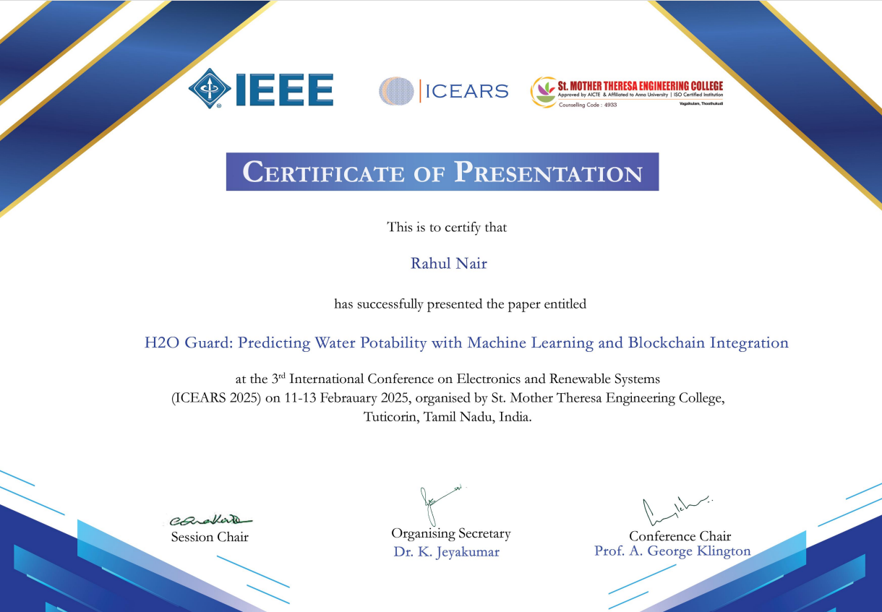

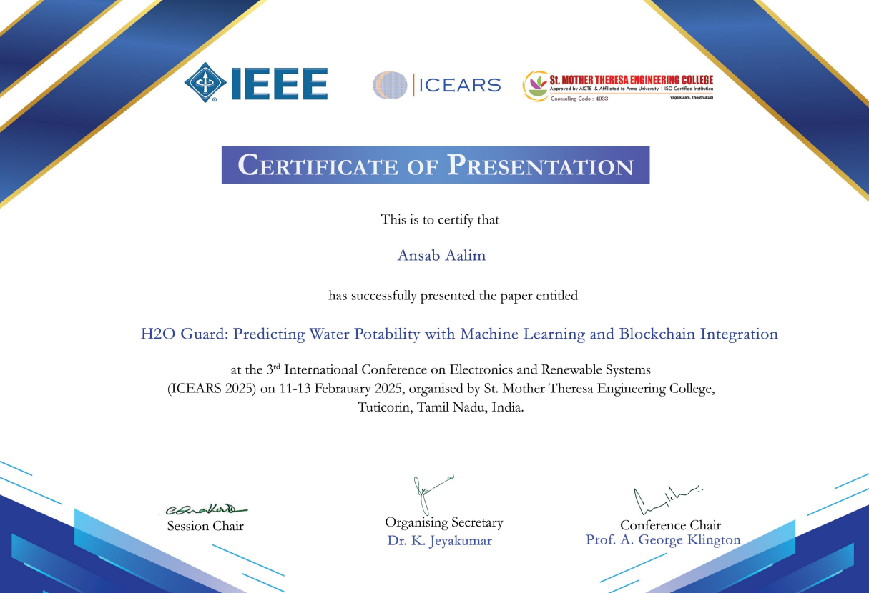

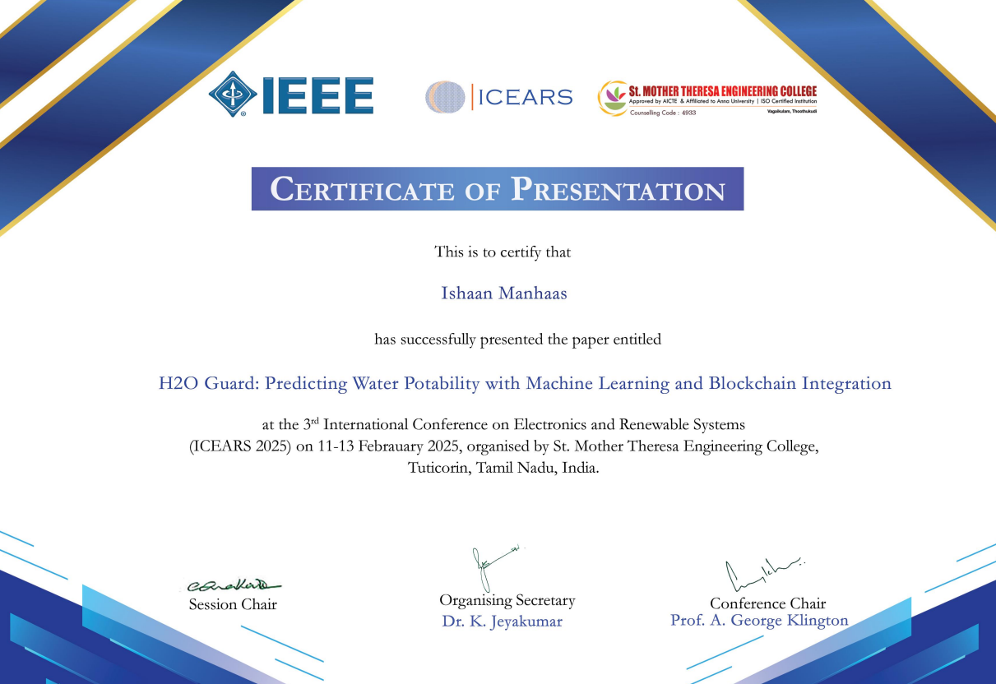

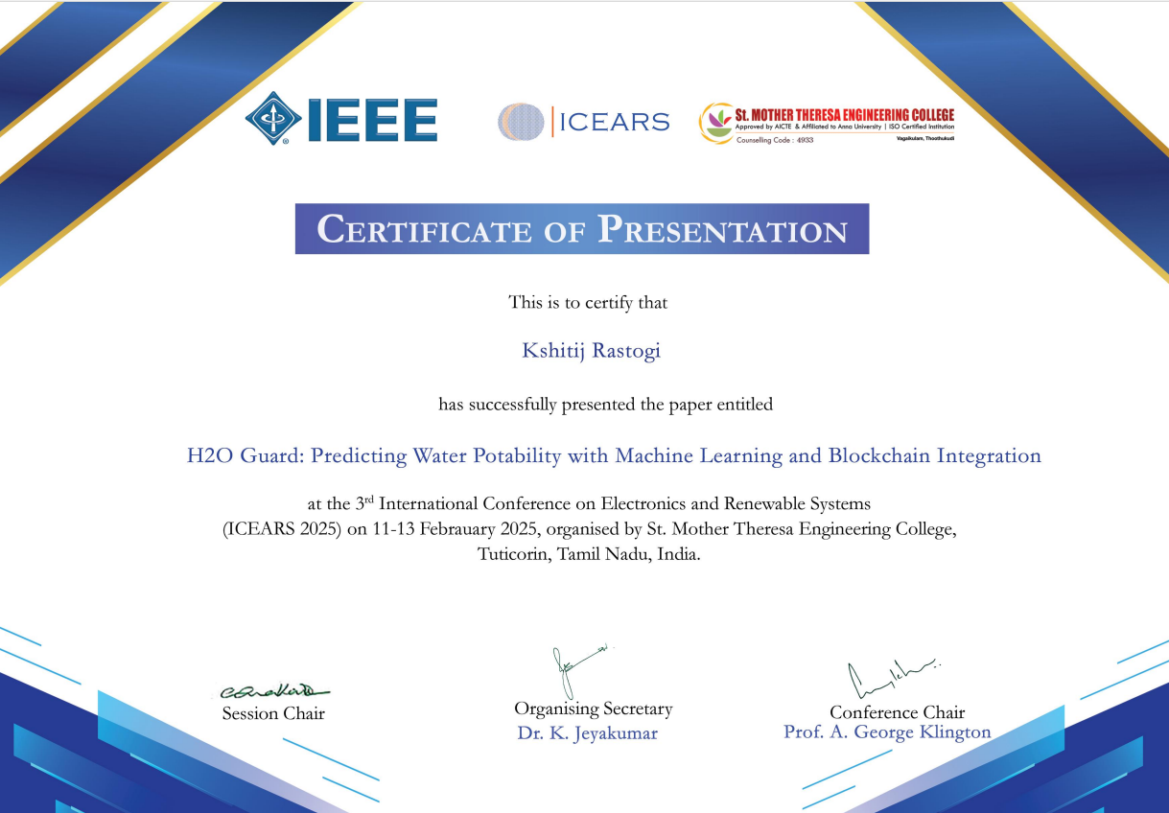

**PLAGIARISM REPORT**

